Roster Management
Once the ILT Session has been created, you may now manage the roster (add, update, reconcile, etc.).

Adding Users to the Roster
- Locate the ILT Event you wish to work with from the Manage Events & Sessions Screen
- Once found, click on the View Sessions Icon
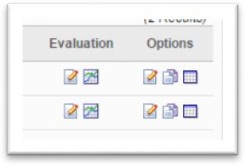
- All the sessions are then presented for the ILT Event
- Locate the desired ILT Session, once found, click on the View Roster icon.
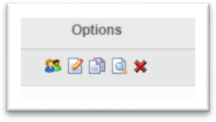
- The Roster interface is presented
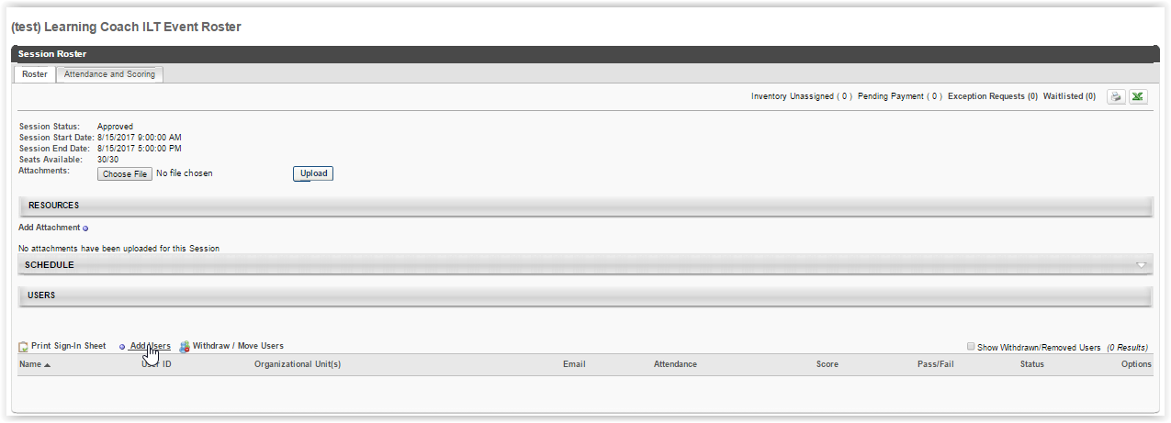

- Use the Choose File to attach your paper roster (sign-in sheet) and evaluation and click Upload.
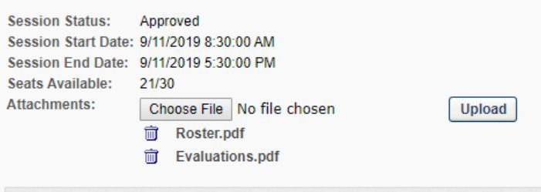

- Users (if any) on the roster are presented at the bottom of the screen
- To add users, click on the Add Users link in the Users section

- The Select User screen appears, where you may enter criteria and search for the desired user(s). Please note that only users with an active my.net/SLU account will appear and can be added to the roster.
- Once the desired user is found, click the icon next to their name
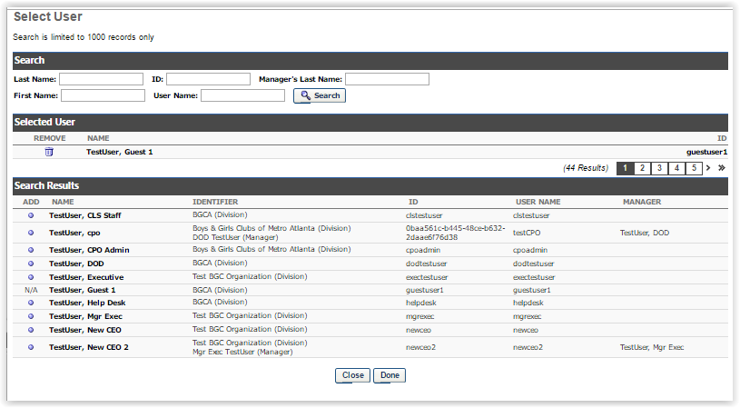
  - This adds the user to the Selected User section of this screen
  - Continue the search and selection process for each user desired to add to the roster
- Once all users have been selected, click the DONE button at the bottom of the screen
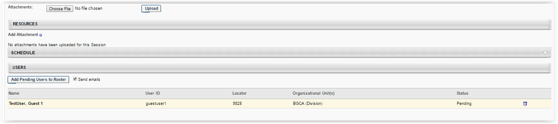
- Verify the desired users are now listed on the roster and their status will be Pending

- To remove any unwanted users, click the trashcan icon next to their name
- Once verified, click the Add Pending Users to Roster button, registering them
NOTE: Button is only available if users have been selected to be added to the session but have not yet been enrolled in it.

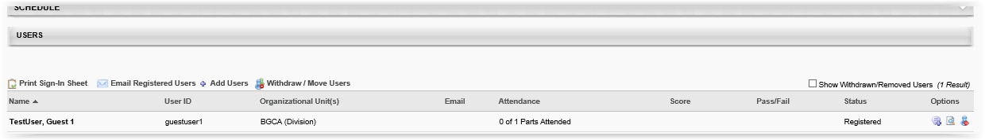

Managing Users on the Roster
Here instructors may perform actions on the roster, including printing the sign-in sheet, emailing registered users, adding users, and withdrawing users or moving users to another session.

Instructors may use the following options to manage users on the roster.

Print Sign-In Sheet | Allows instructor to open and print the sign-in sheet for all users currently in a “registered” status.
Email Registered Users | Opens the WYSIWIG email editor and allows instructor to create and format the email which goes to all enrolled users on the roster.
Add Users | Opens the Select User window, where users may be found and added to the session roster. Users already registered or pending registration cannot be selected.
Withdraw / Move Users | Opens the Batch Window or Move users window, where users may be withdrawn from the session. Once, withdrawn users will no longer appear on the active roster.  To view these users the “Show  Withdrawn/Removed Users” checkbox must be checked.

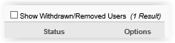
Additionally, there are options for each user available

 | Comments | In the Post Comment popup enter the freeform text of the comment desired to be added for the user. Any existing comments will appear below the comment entry box giving the name of the person who provided the comment and the date added. These may be removed as well by clicking the trashcan icon.
 | History | Simply displays the history log of updates to the user’s roster record for this session.
 | Remove User | Removes (withdraws) the user from the roster.

Reconciling (attendance) Users on the Roster
- Repeat the steps to locate the ILT Event and Session desired and click the View Roster icon
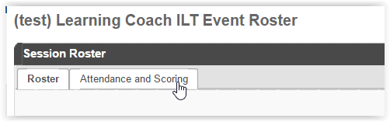
- On the Session Roster interface, select the Attendance and Scoring tab
- The Attendance and Scoring table displays attendance related information for each user that is registered for the session.
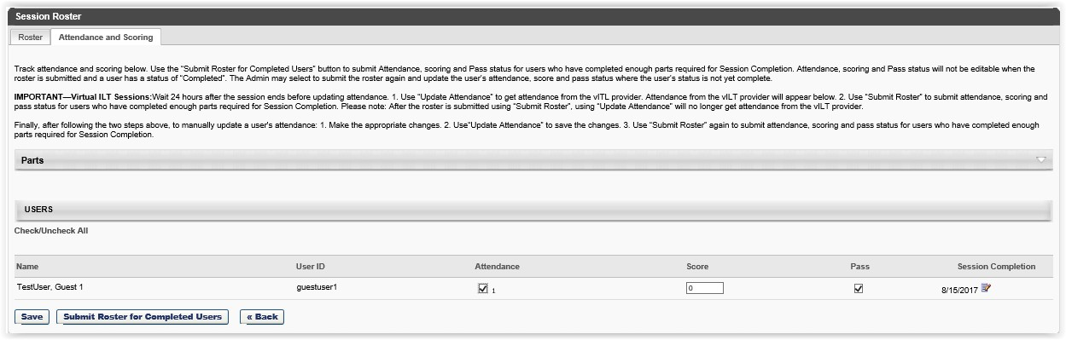
- Attendance – check this box to indicate the user’s attendance
- Score – enter the user’s score if applicable
- Pass – ensure checked if the user’s score was passing (uncheck if not)
- PLEASE NOTE: If the user had a passing score OR passed by attendance and no score is needed, ensure that the ‘pass’ option is checked for all attendees. If they did not pass OR did not attend, uncheck the ‘pass’ box.
- Session Completion – by default this is session end date, however it may be modified by clicking the calendar icon
- Click the SAVE button
- At this point the information has been saved but the roster has not been submitted for completion. The user will still appear on the roster as Registered

- To submit attendance information for the roster and update the user’s status to “completed”, click the Submit Roster for Completed Users button

ATTN: Submit Roster for Completed Users – Once a user has been marked complete on the roster, Attendance, Scoring and Pass status is NOT be editable for that user. ONLY users on the roster who are not yet “completed” may be updated.

