SLU Navigation – Manager Guide
Table of Contents
Viewing Your Subordinates 2
Universal Profile 2
Snapshot 3
Transcript 3
Assign Training 5
Remove Training 8
Reporting 8
Standard Reports 8
Reporting 2.0 10

Viewing Your Subordinates

Universal Profile
Click your name to access your Universal Profile.
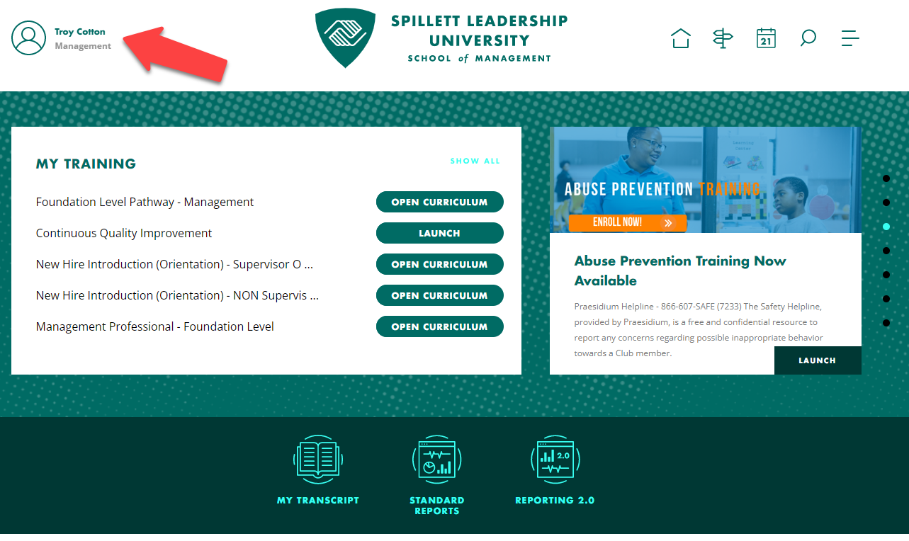
Click on View Team. A flyout window will appear from the left side of the screen.
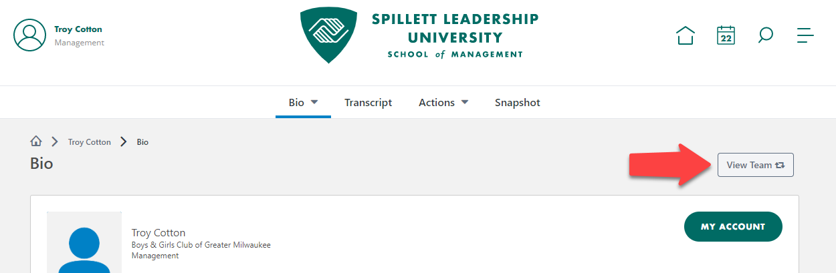
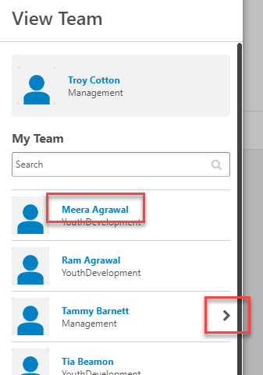
If you have managers on your team, you can also drill down to see any subordinates in your reporting hierarchy.
Click the name of the person you wish to view. This takes you to their Universal Profile. You can access different areas of the system for your subordinate from here.

Snapshot
From the Snapshot area, you can view any competency assessments that your subordinates have taken or view any development plans they have in progress or completed. Click the corresponding tiles to view.
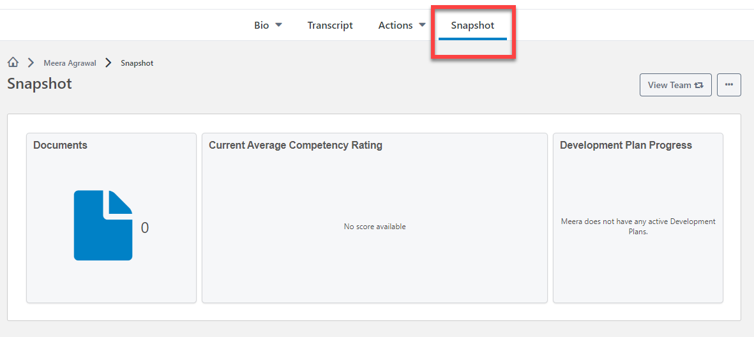

Transcript
From the subordinate’s Universal Profile, click Transcript to view their SLU transcript.
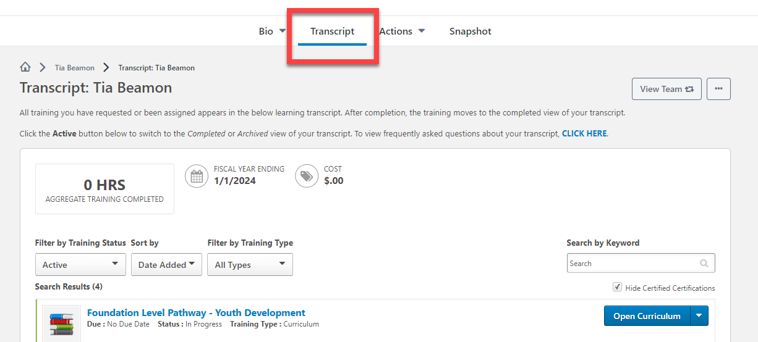
Quick Tip: To view a subordinate’s transcript, you can also navigate to your own transcript from the main SLU home page, then click View Team and select the person you wish to view.
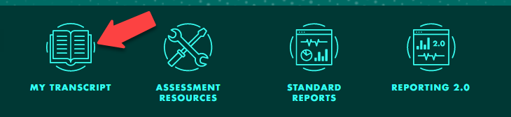
From the transcript page, you can see what training your subordinate is currently taking or has completed in the past.
To switch between in progress training and completed training, click the Training Status menu and toggle between Active and Completed. You can also view any Archived training as well.
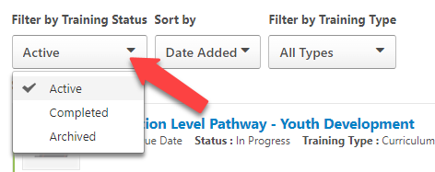
As a manager, you can view training details for items on your subordinate’s transcript, see the status of their training items, such as registered, in progress, or past due, and view any due dates.
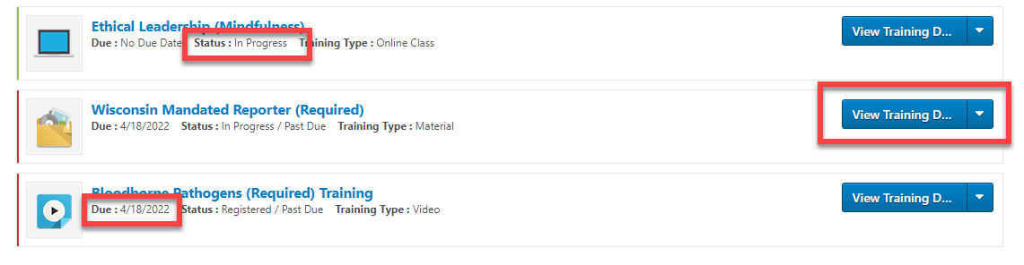
You can also Assign Training directly to a subordinate by going to their transcript and clicking Assign Training. If you want to assign one training to multiple subordinates or learn more about assigning training, go to the Assign Training section of this guide.
You can also export the Transcript to a PDF, if needed.
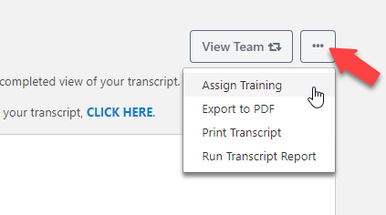

Assign Training
You can assign a training item to multiple subordinates at a time.
First, search for the training item you’d like to assign by going to Browse Training at the bottom of the SLU Home page.
Click on All Training.
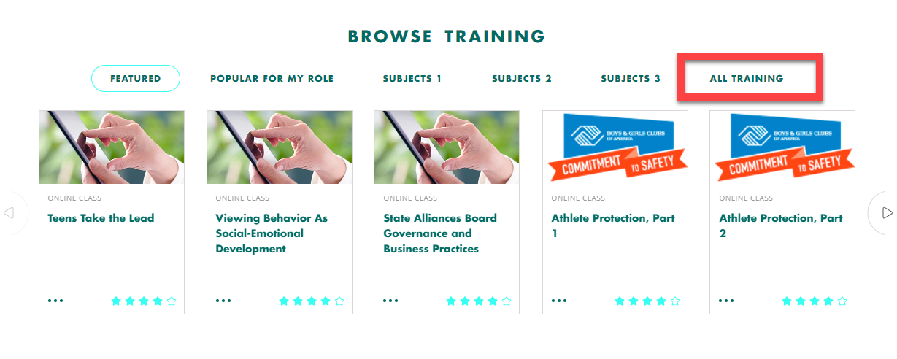
Search for the training title or topic on the Learning Search page.
If you know this is the training you want to assign, you can click the three dots and click assign directly from the menu.
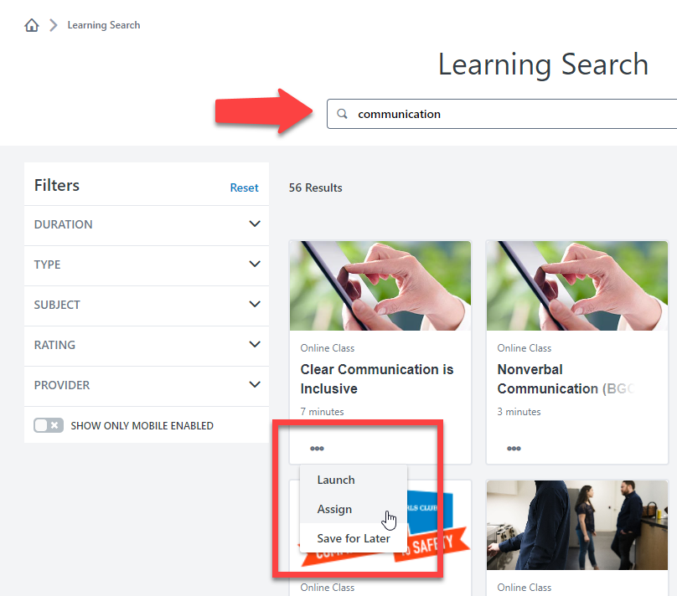
If you want to know more about the training, click on the training title to view the details page, which will include the training description.
From there, if you want to assign the item, click on the Assign button.
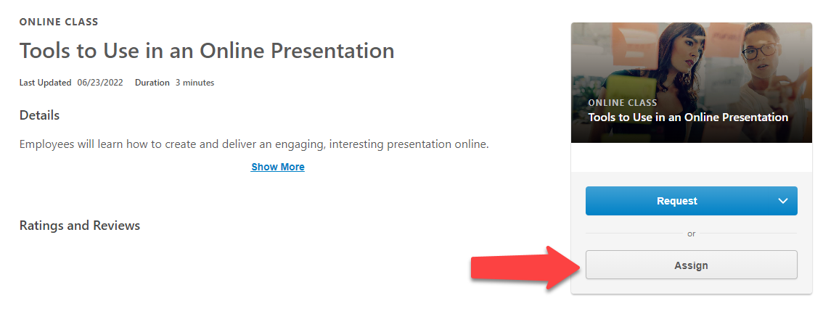
A new page will open showing a list of your subordinates. Click the check box next to the name of any subordinates you wish to assign the training to. You can also include a due date, if needed.
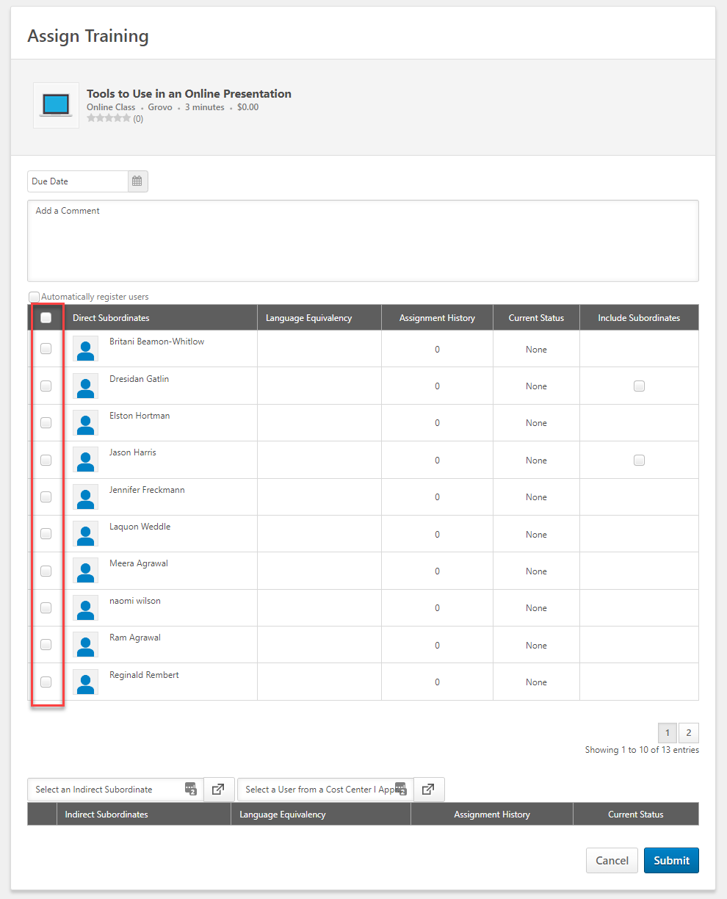
If you want to include any indirect subordinates, you can check the box under “Include Subordinates” for that manager.
A list of the people who report to that manager will show at the bottom of the page. From that list, you can also remove indirect subordinates who you don’t want to assign the training to by clicking the “x” icon next to their name.
You can also type in the name of indirect subordinates to add them directly if you don’t want to check the box to add in all subordinates under a manager.
Once you’ve made your selections, click Submit to assign the training.
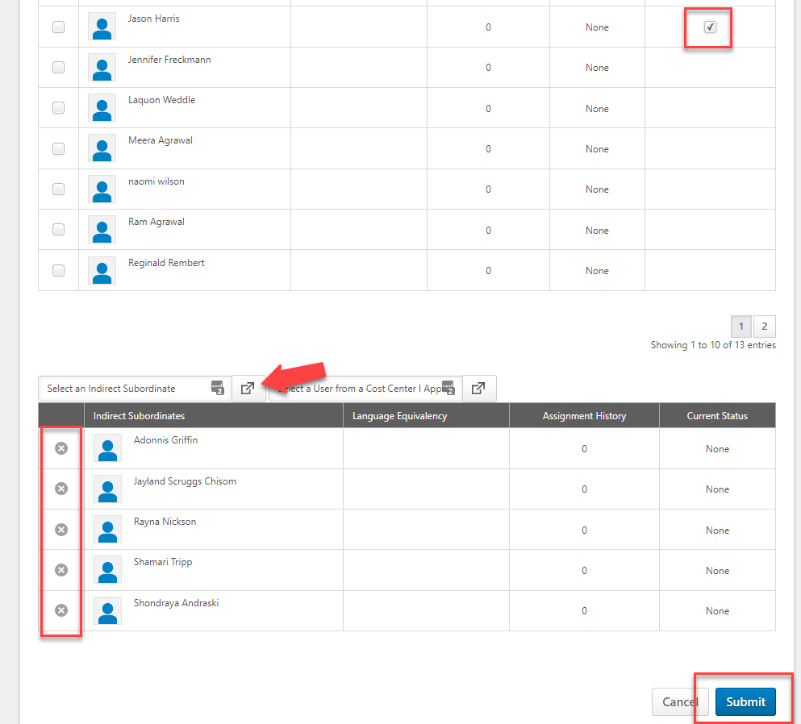

Remove Training
You can remove training that you have directly assigned to your subordinates.
Navigate to the person’s transcript, then click the dropdown menu for the training item you wish to remove.
Click Remove from the menu.
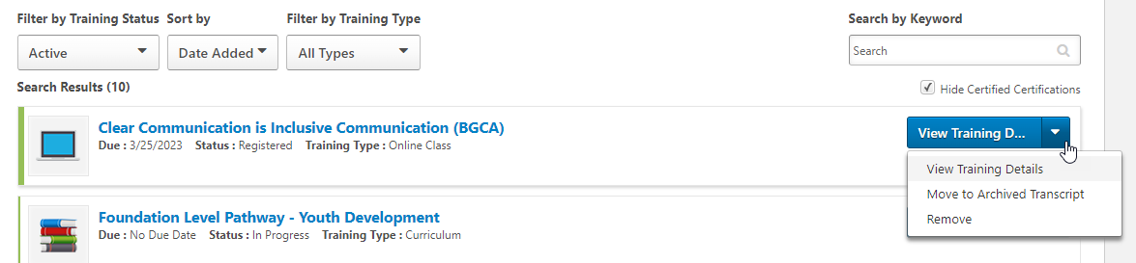
You will then select a reason for removal, enter any comments, and then click Submit.
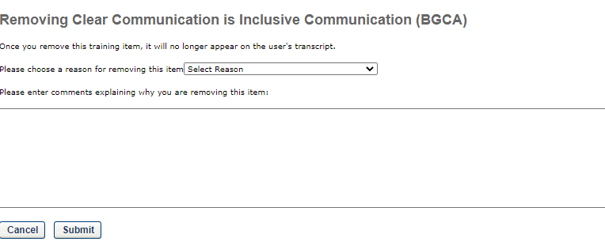

Reporting

Standard Reports
Standard Reports are preset reporting that you can use to pull information from SLU.
Click on the Standard Reports icon on the SLU home page.
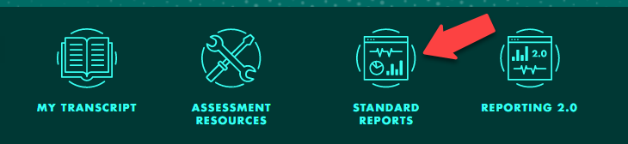
There will be different tabs at the top of the Reports section depending on what is available to you. For our example below, we’ll look at the Track Employees area, but you can also click the Training tab to see more reporting options.
All standard reports are pre-built with options you can choose. The options may look different for different reports, but the mechanics to run the report remain similar.
To run a report, click the title.
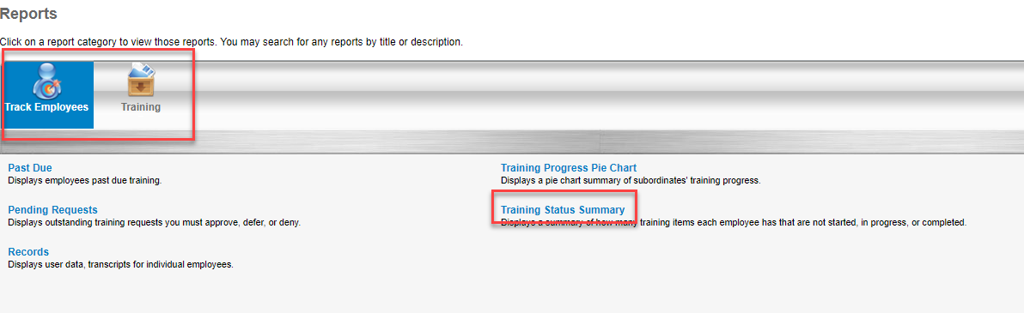
Select any options you choose to customize the report output. Click Search when done.
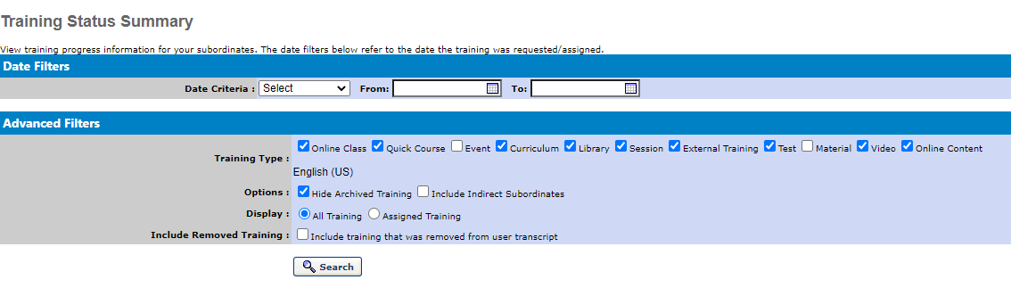
The report output will display. There may be charts included with some reports. The report data will also display at the bottom of the page. You can click on Export to Excel to export the report into an Excel spreadsheet or click Printable Version to pull up a printable report window.
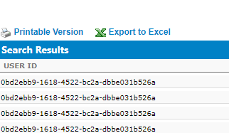

Reporting 2.0
Reporting 2.0 contains custom reports that have been built and shared with you. You can run these reports on demand and choose different filter options to change output.
Click on the Reporting 2.0 icon on the SLU home page.
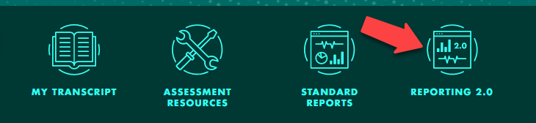
If no adjustments are needed, you can click the arrow icon under Actions to download the report as a CSV file or click the Excel icon to download the report as a formatted Excel spreadsheet.
If you want to adjust the filters or view the report data inside the system, click the report title.
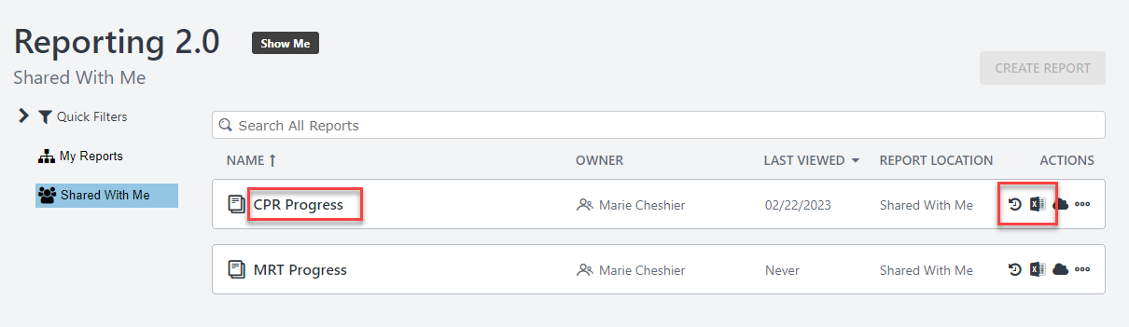
Filters that are available to you will be visible at the top of the page, and you can adjust the ones that allow changes. Once you’ve made any changes, you can click the refresh icon to re-run the report. You can also download the report to CSV or formatted Excel from this page as well.
