Learning Event Registration – Quick Reference Guide

Getting Started

- Log on to MyBGCA.net and click on the SLU icon.

- First time users will be required to complete the MyBGCA.net member profile information to access Spillett Leadership University as follows, returning users skip to step 4:

a. Review/update your MyBGCA.net member profile. If you already have an account, then you will log in.
However, if you do not have a MyBGCA.net account, you will need to click “New myBGCA Account”

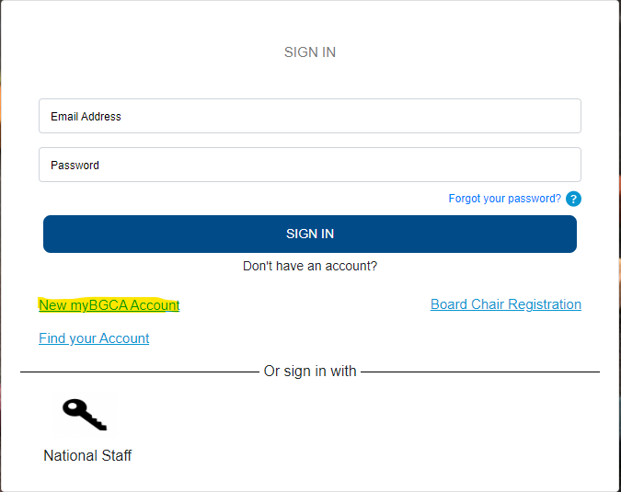

NOTE: Please verify your affiliation and position and update if necessary. Depending on the Professional Category associated, you may be asked to respond to a follow up question.

b. Complete the fields below, Confirm the information is accurate and click Submit.

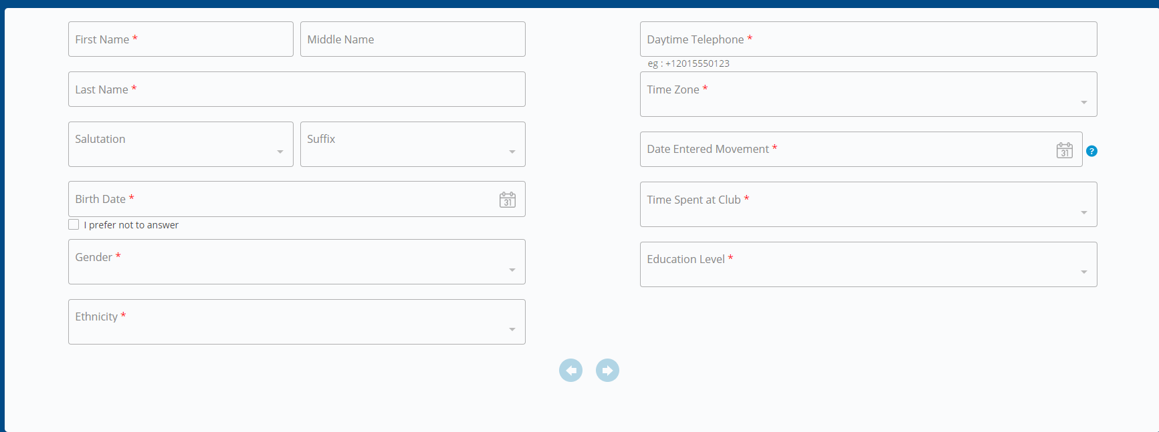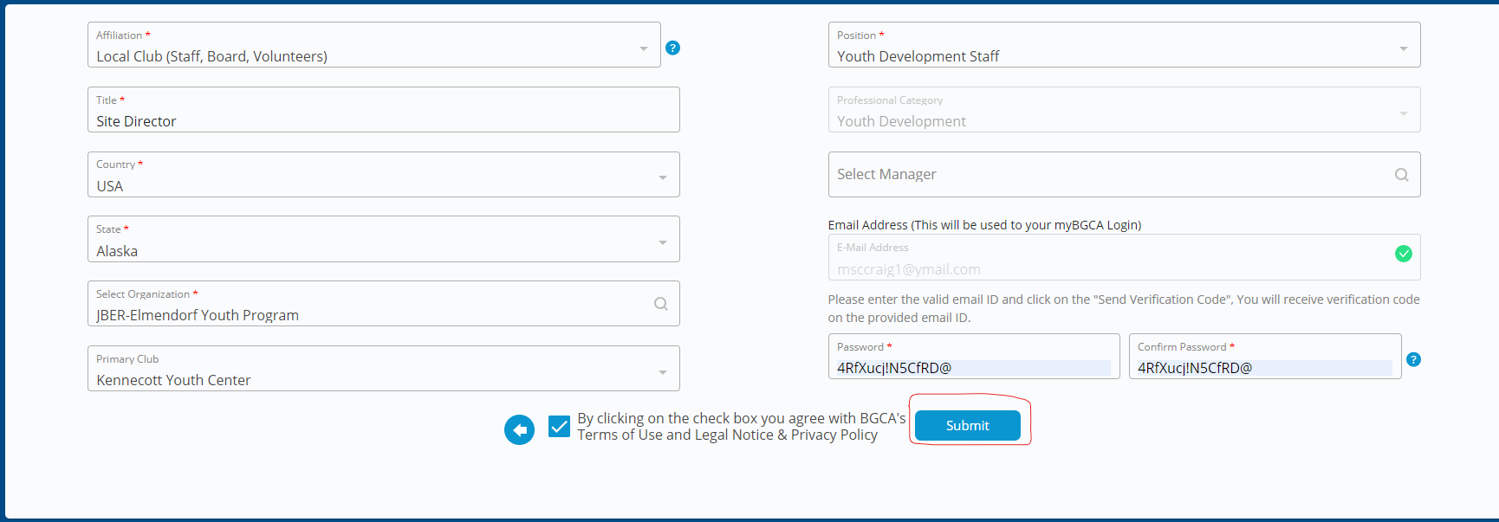

- Once you are logged into MyBGCA.net, click on the Spillett Leadership University (SLU) icon and you will be taken to the appropriate welcome page for your professional category.
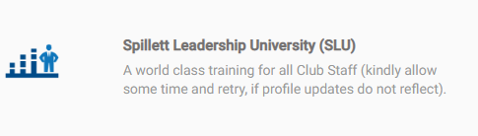

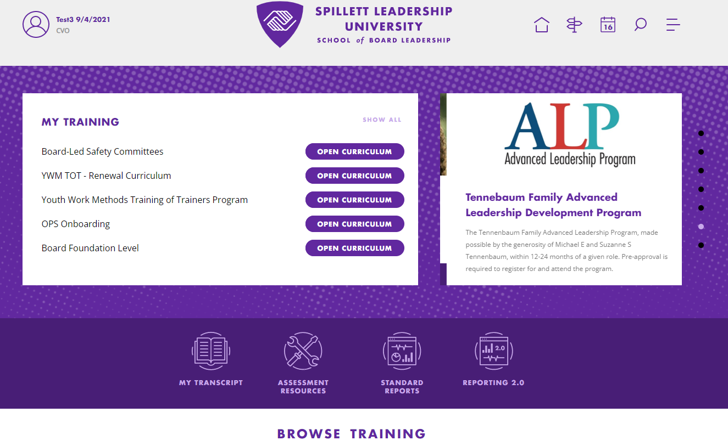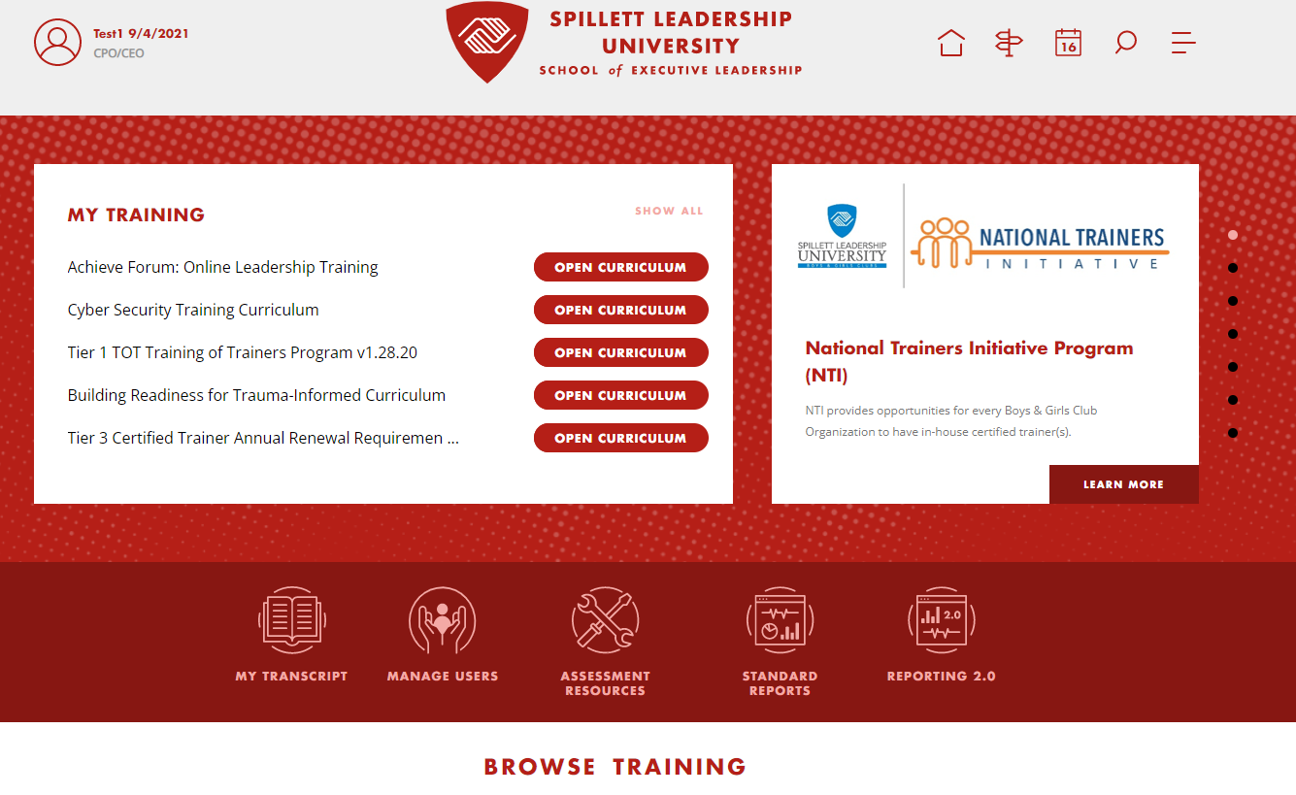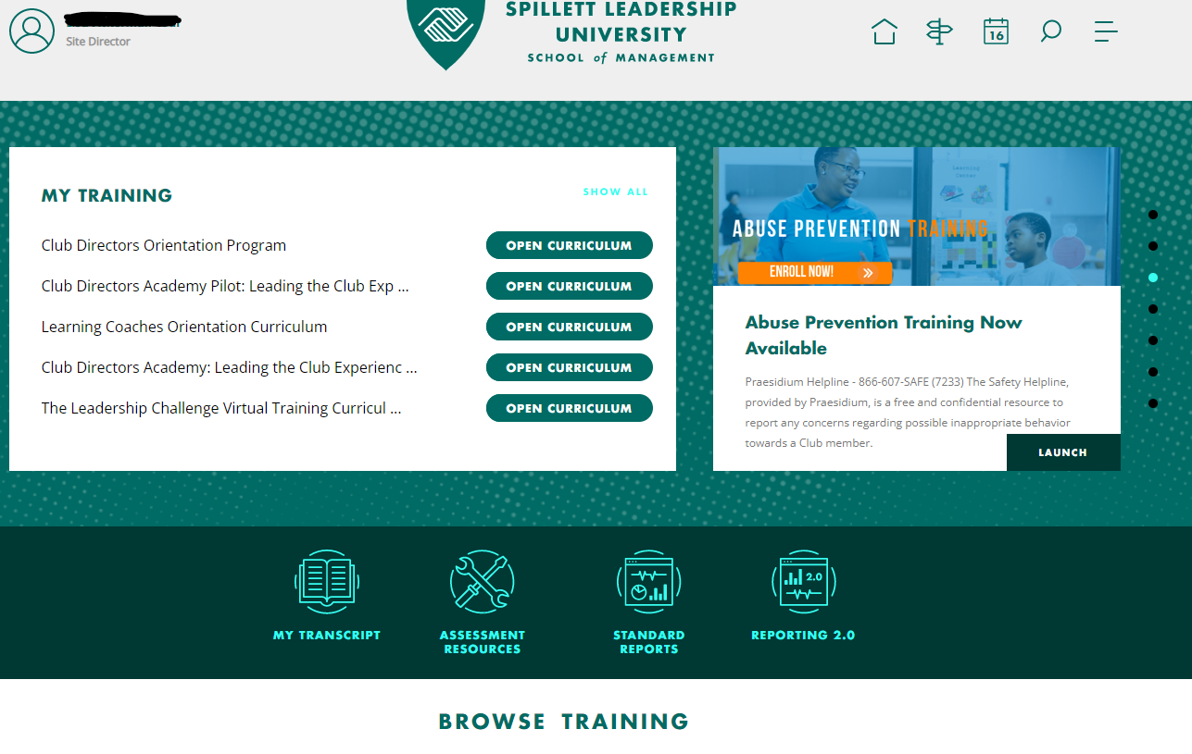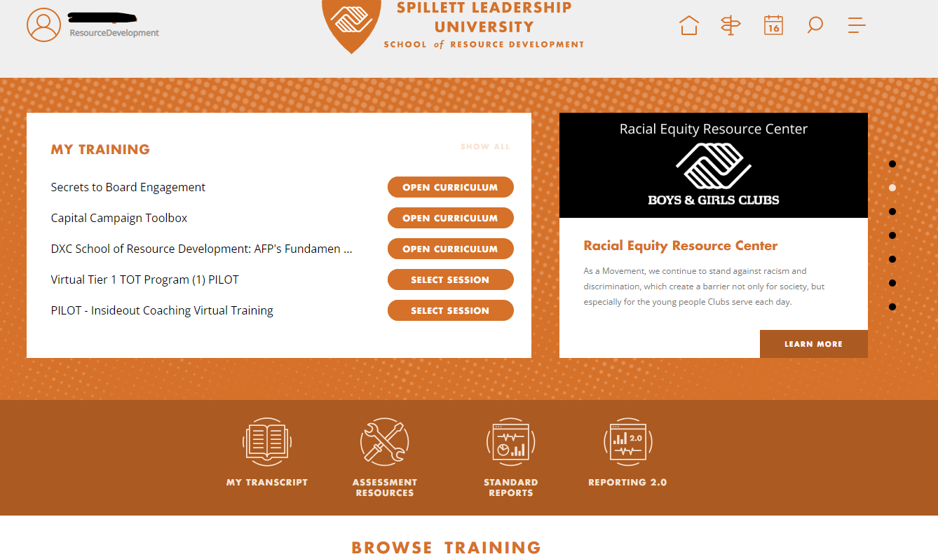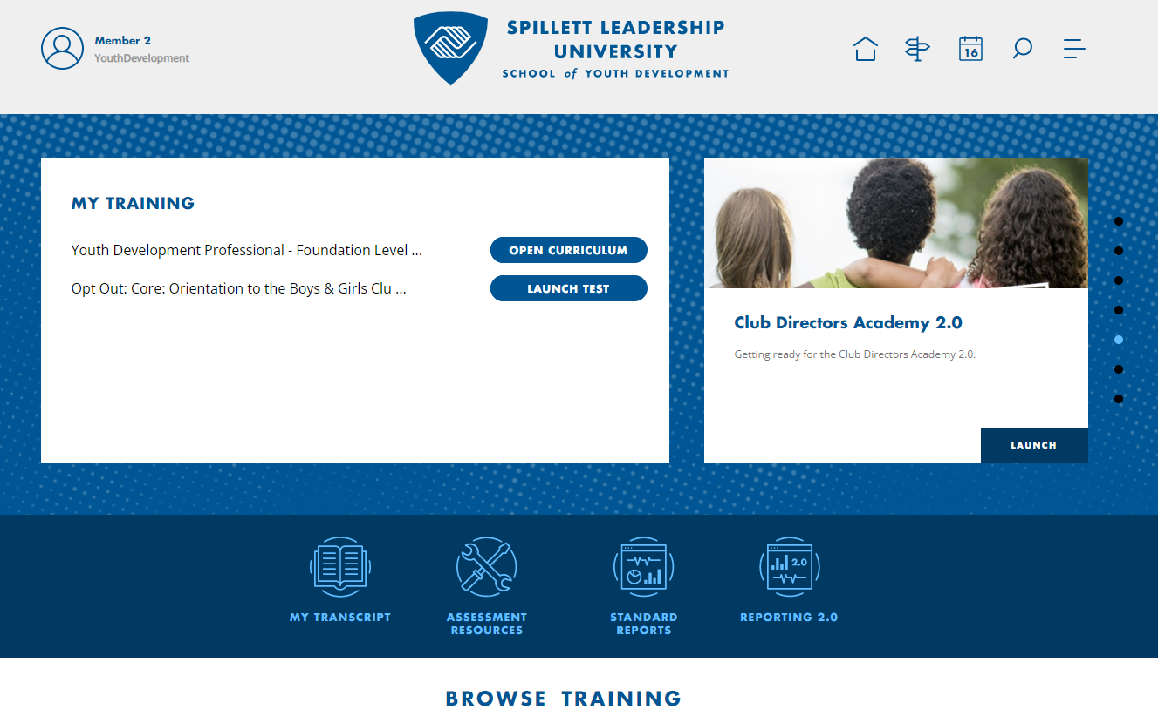

- Once inside Spillett Leadership University, click on the menu icon at the top right of the
home page, click on drop down menu next to “Learning” and then click on “Event Calendar” to access the Training Calendar.

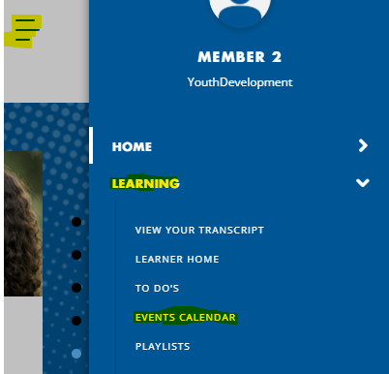

- From the Training Calendar, you can use the event filters on the left to narrow your search or search by date and name of learning event and click on the event name to begin registration.

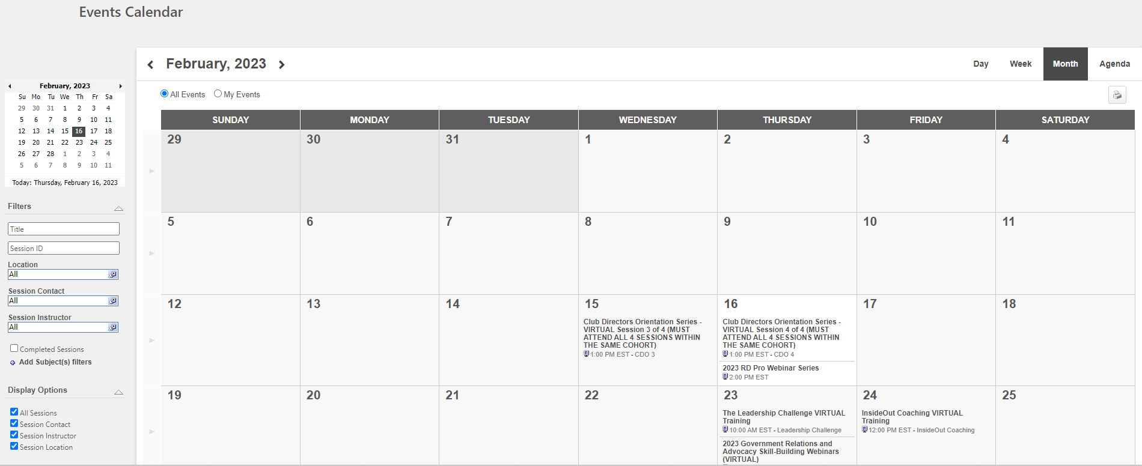

- You will then be directed to your registration page.

Note: Due to recent technical issues recently identified, Spillett Leadership University recommends that learners install the latest google chrome update as this includes coding to correct previously identified bugs. Please follow the instructions noted below to verify current version and install most recent version if needed.

To manually update to the latest version click the Options > Help > About Google Chrome.

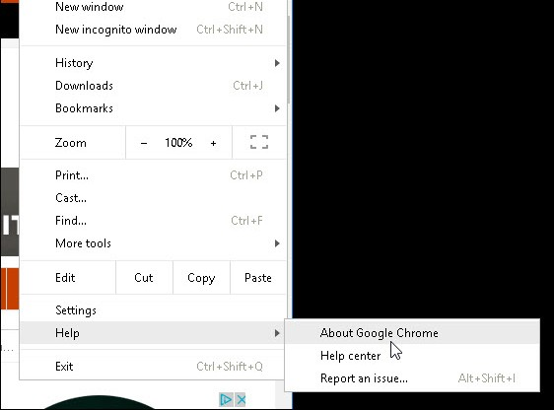

There you’ll see the current version you’re running and that an update is available. Click Relaunch, and it will update it to the latest version which should be v58.

