Contents
Learning Coach ILT Administration Overview 1
ILT Session Creation 1
Enter Location 4
Roster Management 8
Adding Users to the Roster 8
Managing Users on the Roster 10
Reconciling (attendance) Users on the Roster 11

Learning Coach ILT Administration Overview
Learning Coaches have the ability in Spillett Leadership University (SLU) to create and manage Instructor Led Training (ILT) Sessions (i.e. classroom training), as well as manage the session rosters. This guide provides the steps and processes to create and manage the ILT sessions and the rosters associated with them. Please note that in order to have permissions to manage your events, you must complete the “Learning Coaches Orientation Curriculum” within SLU. Once completed, there will be up to a 6-hour lag time before access to these permissions are made available to you.

ILT Session Creation
- Logon to MyBGCA.net and access Spillett Leadership University (SLU)
- Click on the menu icon at the top right of the home page and then click ILT > Manage Events & Sessions

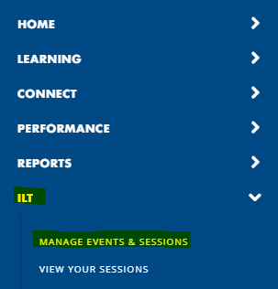

- Enter criteria (optional) and click SEARCH to locate the ILT Event (i.e. training) you need to create a session OR just click on the SEARCH button to view all Learning Coach events.

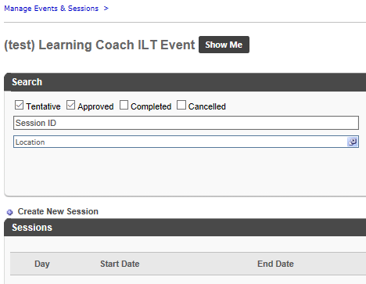
- Once the ILT Event desired is found, click the View Sessions icon [ ]
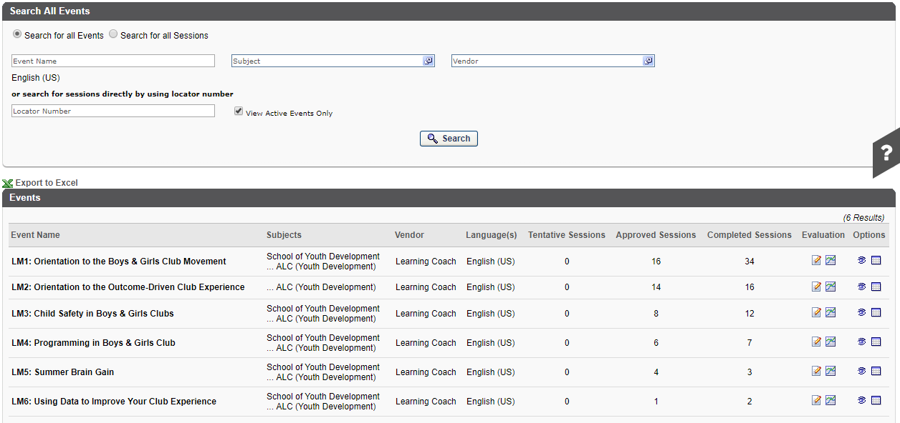

- Click to create and begin the process

- Enter the options for the session in the Schedule Wizard
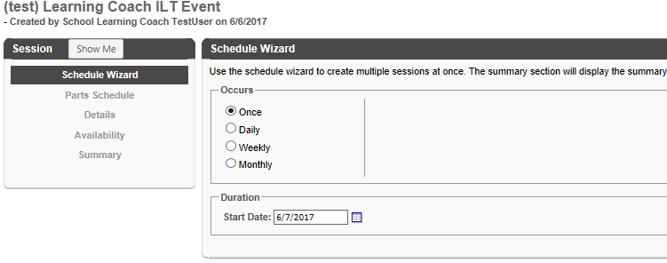

Name | Description
Schedule Wizard | The Schedule Wizard helps establish the frequency of the ILT. They can be offered in the following manner:  - Once  - Daily  - Weekly  - Monthly  Also, the start date for this ILT is selected.  When selecting a recurring ILT there will be options for selecting the start and end dates, the frequency, or any other specifics needed to ensure scheduling meets user’s requirements.
Parts Schedule | Each session can be broken up into parts if required to provide even further detail of the ILT. For example, there could be an ILT that has a session that is a full day of training. This training could be broken up into 2 parts, one for the morning and the other for the afternoon. The Parts Scheduling can provide the details as to when the activity will start, have breaks, and ultimately end.  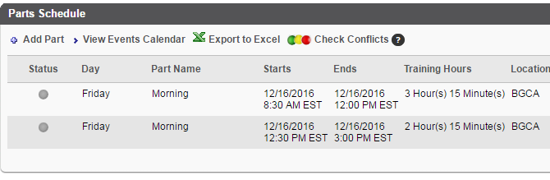
Details | The details page covers details of the ILT such as the setting instructors, learning outcomes, KPI’s. Specific attachments needed for the session can be added at this point. Specific registration information can also be configured at this point.
Availability | Sets who may register for and access this session as well as any specific requirements, such as approvals, for those users and this ILT Session.
Emails | Selects the sort of notification emails that a user will receive for this activity. The options are to either utilize system default email notifications, to not use email notifications, or to customize what notifications are to be utilized.
Pricing | Configures any pricing structure utilized for this learning activity
Summary | Provides a summary of the options selected in a single displayable page

- In this example, we are creating a one-day session that starts on August 15, 2017
- Click Next
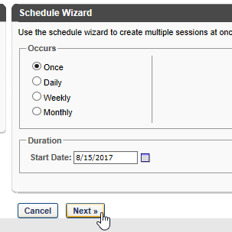

- Enter the name for the session (e.g. NY / NY 9am - 5pm Session)
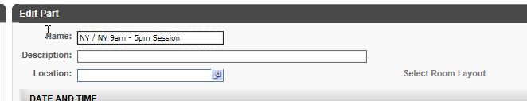

- Select the location by clicking the selection action item next to the entry box
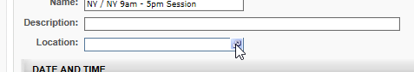

Enter Location
Your location should always be your Club’s Parent Organization, NOT the Club site.
- You can search for the parent organization by typing part of the name in the Name field and then click on the Search button. Select the desired location by clicking left of the Location Name.
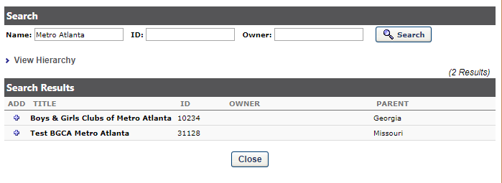
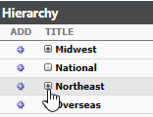
- Or, search and select the desired location using the expand icon [] to drill down into the children of a location and then click left of the Location Name.

- Click DONE on the next screen
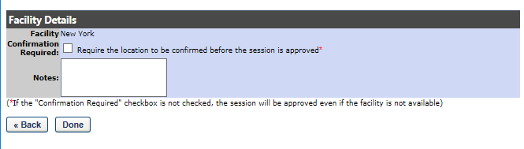

- Click DONE on the next screen

Select Instructor(s)
- Please skip this step.

- Set the Start Date / Time and End Date / Time
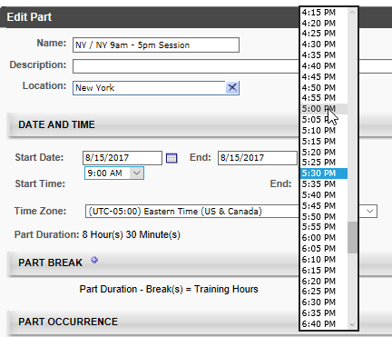

- Click Save Part at the bottom of the Schedule Wizard
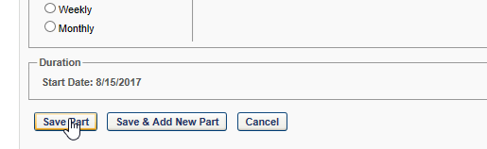

- Confirm the session part has the correct information (start / end | location | instructor) and click NEXT >>
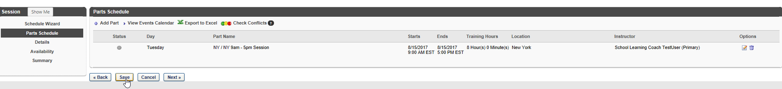
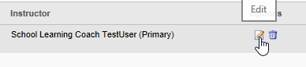
NOTE: if you need to make changes click the Edit icon

- Enter the Details for the Session | NOTE: Session ID is not required and may be left blank. This information is NOT needed for internal and past events.
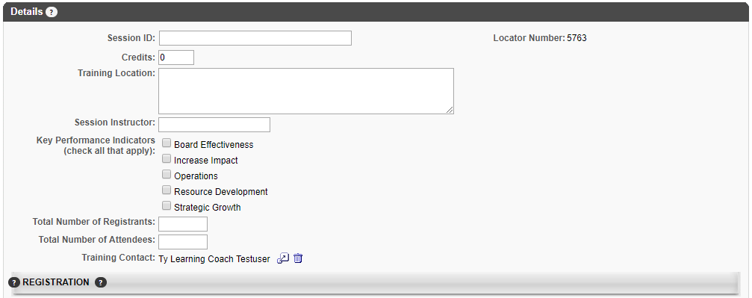

- Enter or Update the Registration information OR leave defaults.
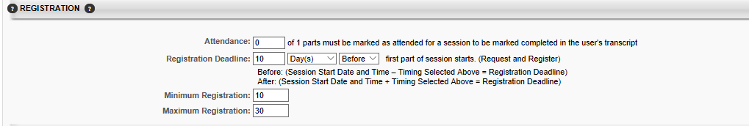

- Update waitlist information if necessary OR leave defaults.
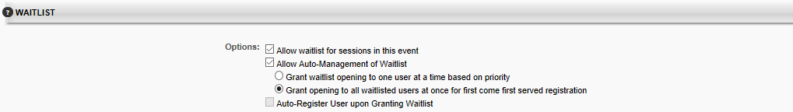

- You will NOT have the ability to add prerequisites, pre-work and post-work.

- Click the Next >> button at the bottom when you have entered and verified the information.
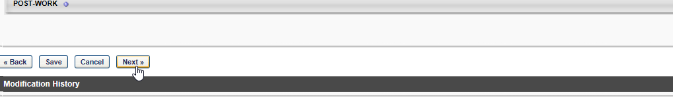

- On the availability screen click the Next >> button

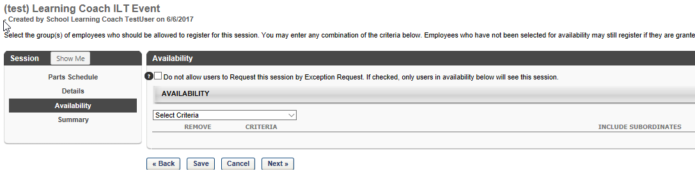
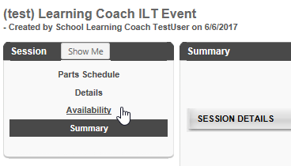
- Verify the information on the Summary Page and once satisfied click the Save button at the bottom of the page.

NOTE: Use the links on the left or buttons on the bottom to go back and make any needed changes.

Roster Management
Once the ILT Session has been created, you may now manage the roster (add, update, reconcile, etc.).

Adding Users to the Roster
- Locate the ILT Event you wish to work with from the Manage Events & Sessions Screen

- Enter criteria (optional) and click SEARCH to locate the ILT Event (i.e. training) you need to create a session OR just click on the SEARCH button to view all Learning Coach events.

- Once the ILT Event desired is found, click the View Sessions icon [ ]

- All the sessions are then presented for the ILT Event
- Locate the desired ILT Session, once found, click on the View Roster icon.
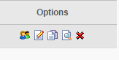

- The Roster interface is presented
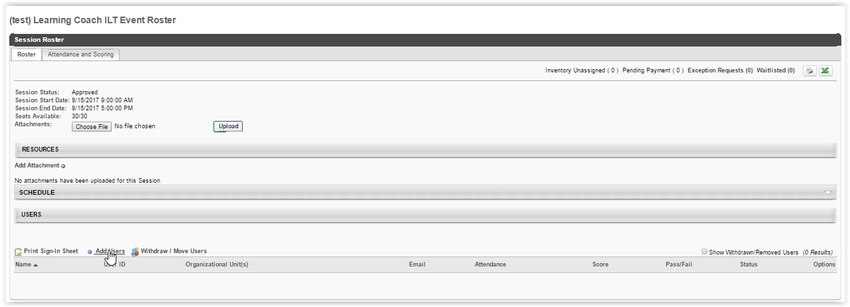

- Users (if any) on the roster are presented at the bottom of the screen.
- To add users, click on the Add Users link in the Users section
- The Select User screen appears, where you may enter criteria and search for the desired user(s). Please note that only active Spillett Leadership University (SLU) users will appear.
- Once the desired user is found, click the icon left of the user’s name
  - This adds the user to the Selected User section of this screen
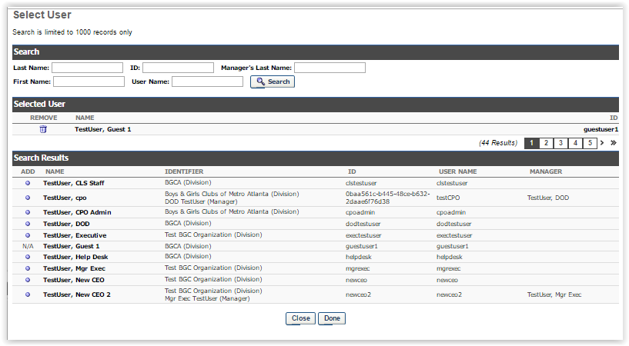
  - Continue the search and selection process for each user desired to add to the roster

- Once all users have been selected, click the DONE button at the bottom of the screen
- Verify the desired users are now listed on the roster and their status will be Pending
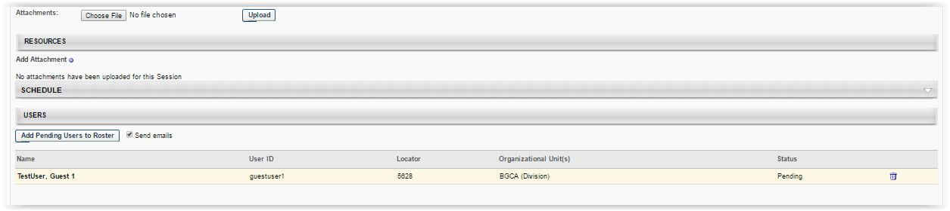
- To remove any user, click the trashcan icon left of the user’s name
- Once verified, click the Add Pending Users to Roster button to register and add users to roster
NOTE: This button is only available if there are users who have been selected to be added to the session, but have not yet been enrolled in the session.

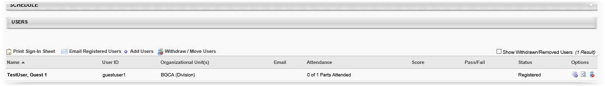
- You must reconcile the roster in order for the session to appear on user’s transcript. Instructions on how to reconcile the roster are listed below.

Managing Users on the Roster
Here instructors may perform actions on the roster, including printing the sign-in sheet, emailing registered users, adding users, and withdrawing users or moving users to another session.
Instructors may use the following options to manage users on the roster.
Print Sign-In Sheet | Allows instructor to open and print the sign-in sheet for all users currently in a “registered” status.
Email Registered Users | Opens the WYSIWIG email editor and allows instructor to create and format the email which goes to all enrolled users on the roster.
Add Users | Opens the Select User window, where users may be found and added to the session roster. Users already registered or pending registration cannot be selected.
Withdraw / Move Users | Opens the Batch Window or Move users window, where users may be withdrawn from the session. Once, withdrawn users will no longer appear on the active roster.  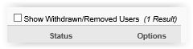  To view these users the “Show Withdrawn/Removed Users” checkbox must be checked.

Additionally, there are options for each user available
 | Comments | In the Post Comment popup enter the freeform text of the comment desired to add for the user. Any existing comments will appear below the comment entry box giving the name of the person who provided the comment and the date added. These may be removed as well by clicking the trashcan icon.
 | History | Simply displays the history log of updates to the user’s roster record for this session.
 | Remove User | Removes the user from the roster.

Reconciling (attendance) Users on the Roster
- Repeat the steps to locate the ILT Event and Session desired and click the View Roster icon
- On the Session Roster interface, select the Attendance and Scoring tab
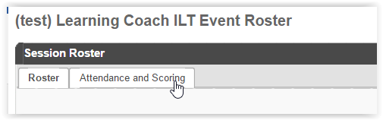
- The Attendance and Scoring table displays attendance related information for each user that is registered for the session.
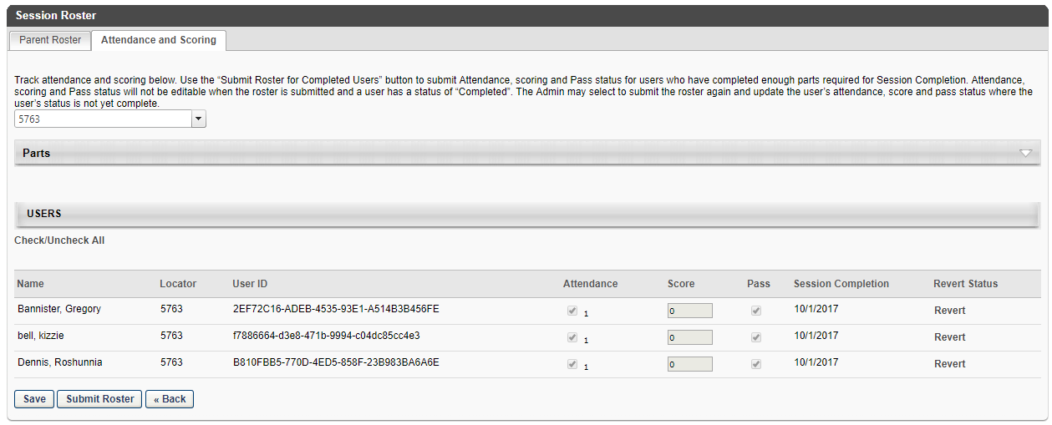

- Attendance – check this box to indicate the user’s attendance
- Score – enter the user’s score if applicable
- Pass – ensure checked if the user’s score was passing (uncheck if not)
- Session Completion – by default this is session end date, however it may be modified by clicking the calendar icon
- Click the SAVE button
- At this point the information has been saved but the roster has not been submitted for completion. The user will still appear on the roster as Registered

- To submit attendance information for the roster and update the user’s status to “completed”, click the Submit Roster button

ATTN: Once the Submit Roster button is selected, Attendance, Scoring and Pass status will NOT be editable for users with a status of “Completed”. ONLY users on the roster whose status is not “completed” may be updated.

