Session Withdrawal Overview

Allows administrators, users, and managers to withdraw from sessions themselves or on their behalf of their staff. This is done from the user's Transcript page.

Session Withdrawal

- Log in to Spillett Leadership University (SLU) via MyBGCA.net.
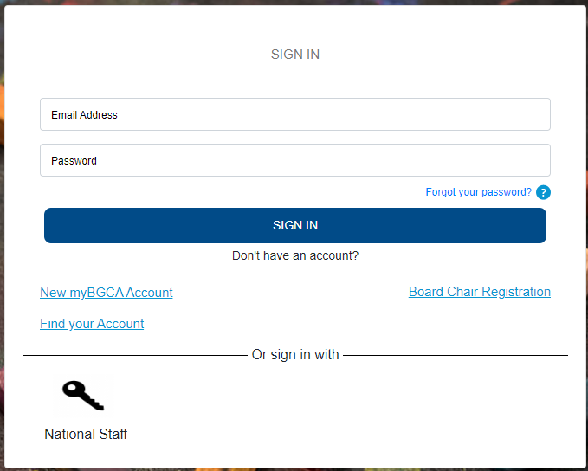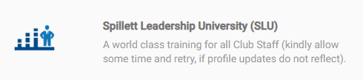

- Click on the transcript icon on your home page.
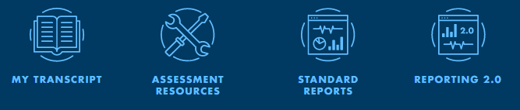

The session may also appear at the top left of your home page under “My Training”, where you can also access the withdraw button without having to navigate to your transcript.
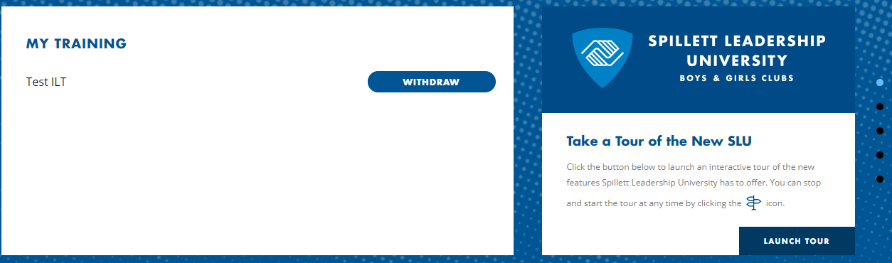

- Click on the drop-down menu next to the event session you want to withdraw from.
- Once you click “withdraw” it will take you to the screen below where you will select a reason for the withdrawal from the drop down menu.

- Enter a comment in the comment box and then click submit.
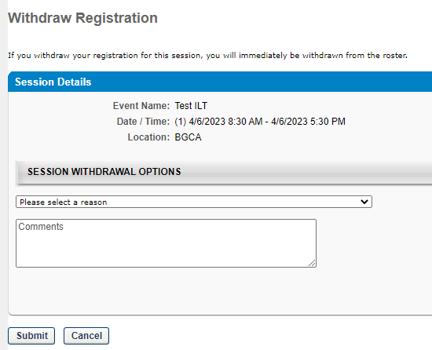

- Once you hit submit, the status changes to Withdrawn and the Select Session option is now available.
Note: If you paid a fee for the session, withdrawing will automatically refund your fee to the card used during registration. Therefore, if you are going to select a new session, you will be prompted to pay again.

