Renewal Reporting Overview
As part of your annual renewal of your Tier 1 or Tier 2 certified trainer status, you will be asked to validate that you have facilitated the minimum number of required training sessions during the past year. This document provides instructions to quickly and easily produce a report of all your past instructor sessions in SLU. Available filters also allow you to limit the date range, etc.

Reporting on Your Past Sessions

- Log in to MyBGCA.net and access SLU and then navigate to ILT > Manage Events and Sessions
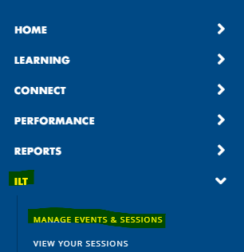
- From the Events and Sessions screen, click the ‘Search for all Sessions’ radio button and wait for the screen to refresh.
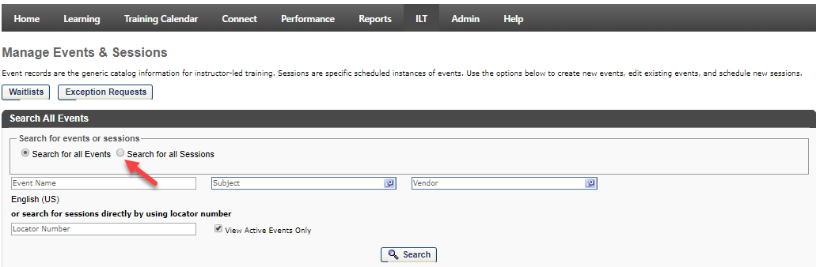

- Click the ‘Complete’ check box to ensure that your previously reconciled sessions are included in the report. Click the ‘Search’ button to produce a list of all past and currently scheduled sessions for which you are the designated instructor. You may also use the date filters to limit the report to a specific period.
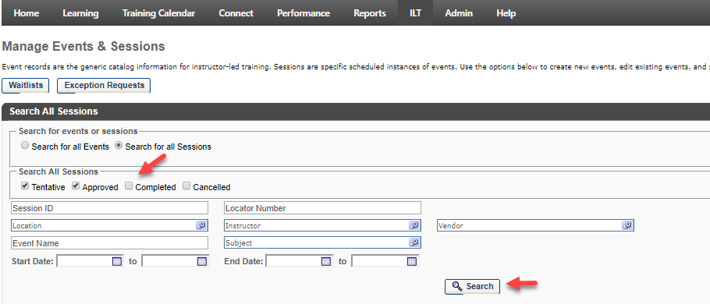
- The screen refreshes with a list of all your sessions. If needed you can adjust the filters to further limit what appears on the report. Notice the on-screen display shows the Event names, the session dates, location and enrollment for your sessions. Click the ‘Export to Excel’ link on the left side of the screen if you wish to save the report to your computer.
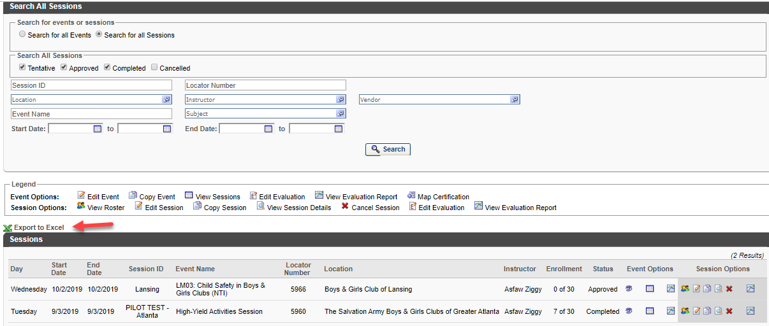

- The key data appears in an Excel table which can then be filtered, sorted, etc.
