Creating a New Instance of a Training
This document provides instructions on how to create a new instance of a completed training quickly and easily with a new completion date on the certificate. Please be advised, this applies to Safety Required Trainings only.

Creating a New Instance of Training

- Log in to MyBGCA.net then click on the Spillett Leadership University icon to access SLU, and then navigate to the search box at the top right. Type in the name of the completed training and click the search icon.
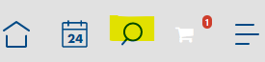

- Once you locate the completed training, you will see the option to “Request” the training. Click the request button.
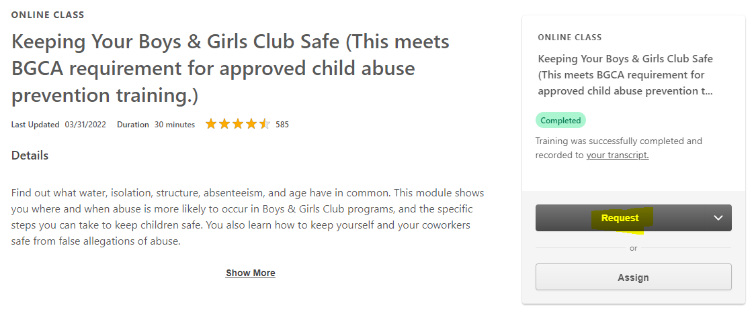

- The system will then alert you that you have already completed the training and click the “Request” button to retake and receive a new completion date.
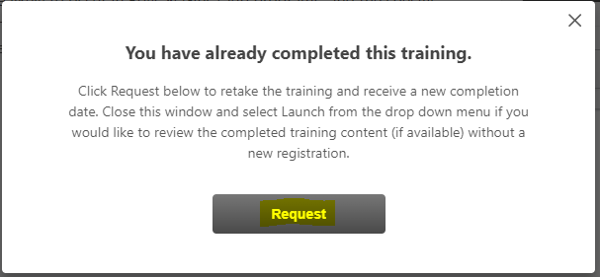

- After clicking the request button, you will be able to launch a new instance of the training. Simply click the launch button to retake the training and receive a new completion date.
