Contents
Competency Self-Assessment 1
Complete Your Competency Assessment Task & Create Your Development Plan 1
Access and Manage Your Development Plan Progress 4
Competency Assessment Summary 5
Access Your Competency Assessment Summary at Any Time 5
Development Plan 6
Editing Your Development Plan 6

Competency Self-Assessment
Complete Your Competency Assessment Task & Create Your Development Plan
1. Log into SLU by logging into mybgca.net, click on Training and then click on the SLU banner on the Dashboard. | 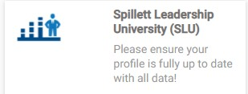
2. From the SLU Home page, click the menu icon at the top right, click to expand the Home tab and click on the Scheduled Tasks link from the drop-down menu that appears. | 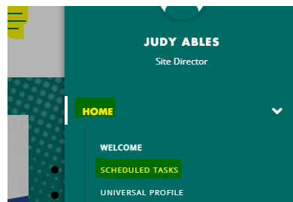
3. Click on the task title to access your self- assessment. Your task title will be specific to your BGC role (e.g., Operations Leader, Club Director, Youth Development, etc.) | 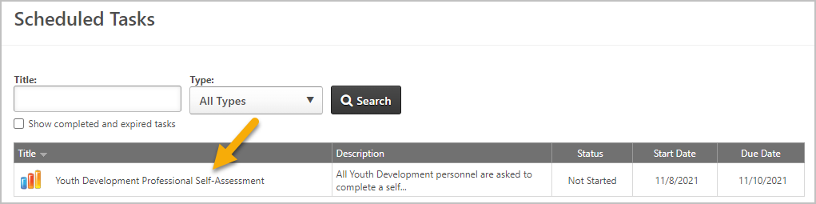
4. Review the Task Instructions and then click  Continue. | 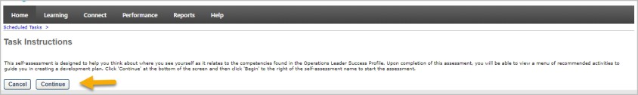
5. Review the additional information and then click Begin to start the assessment. | 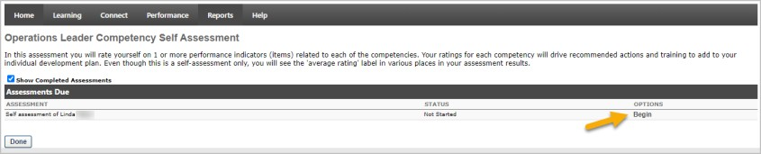

6. Review each competency behavioral statement (item) and select the rating that best describes your effectiveness for it. | 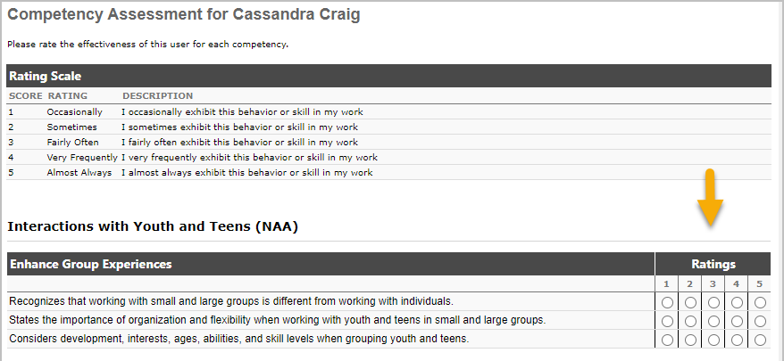
7. After ALL behavioral statements are rated, click on Submit Assessment at the bottom of the screen. NOTE: If you are interrupted before finishing, click Save & Return to preserve your progress. You can reopen
the task later to finish.
8. You are then directed to your Assessment Summary Page. You first see your average ratings by competency Factor (parent category). Click the green or red bar to drill down to view individual competency ratings. Drill down again to view individual item ratings.

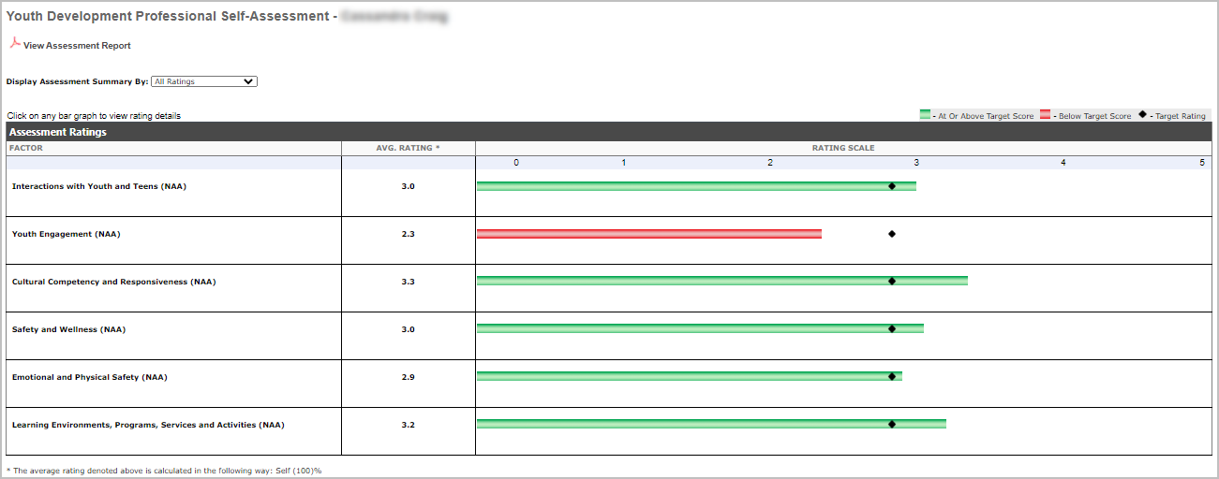

9. Click View Assessment Report if you would like to export your results to a PDF  document. | 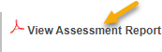

10. Click the Display Assessment Summary By: dropdown selector and click Recommended Actions to view development actions and training that are recommended based on your competency ratings. | 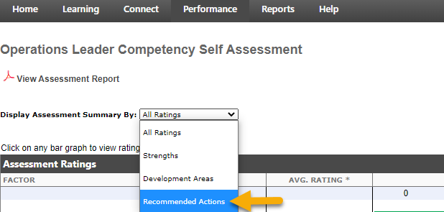
11. A menu of recommended development actions and training appears, grouped by competency. These recommendations appear depending on each competency’s rating. Review the recommendations and click the checkbox to the left of an item if you wish to add it to your individual development plan. You may choose as many or as few recommendations as you believe appropriate. | 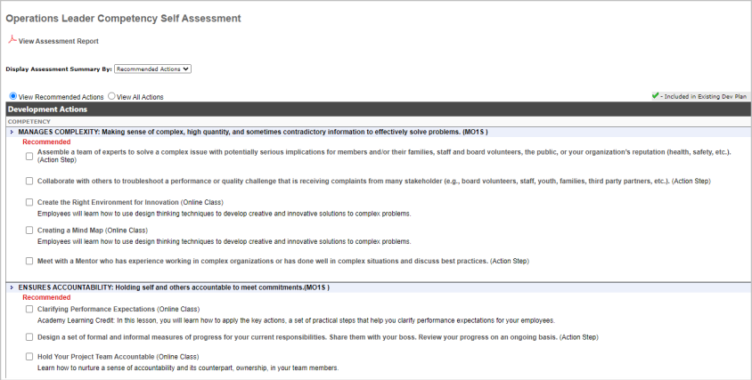
12. When you have selected all the recommendations you wish to add to your plan, scroll down to the bottom of the screen and click the Create Dev Plan button. This will instantly create a development plan for you. If you later wish to return to this screen and add additional recommendations to your plan, you may. Just follow the same steps. Click Done to  exit the screen. | 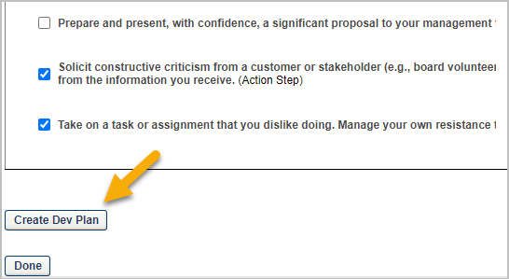

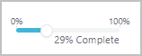
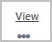
Access and Manage Your Development Plan Progress

1. You can view and manage the development plan you created at any time in SLU by navigating to Performance > Development Plans via the main menu icon. | 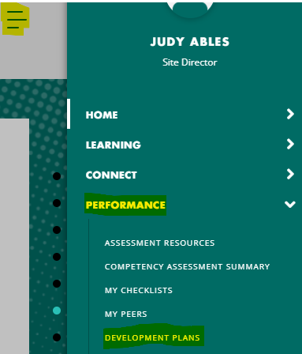
2. If you created your plan from the Competency Assessment Summary Recommended Actions screen, your plan will have the same name as your assessment task. From the Development Plans screen, Click on the name of your plan to view its details and manage progress. You can also open it using the View link from the dropdown menu. | 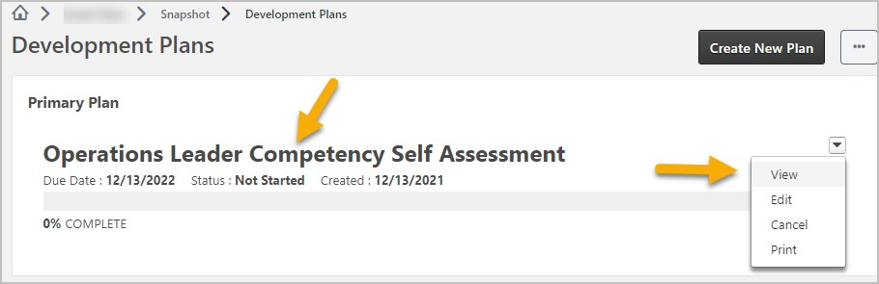
3. Your plan opens, displaying summary information at the top of the screen, including due date and completion progress percent. From the Options menu you can print the plan or edit the plan if needed. | 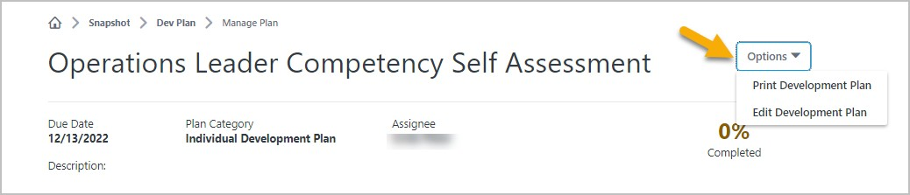
4. Within an Objective, click and drag the Progress Slider right or left to update  progress percent of Action Steps. For Training, click the  View link to view and request the training, or the Launch link to open a course that was previously requested. | 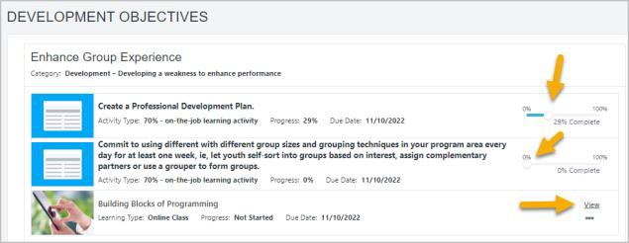
5. The learning details screen opens in a separate window where you can click Launch to begin the training (online courses, videos, etc.) or Register for a session if it is instructor-led training. | 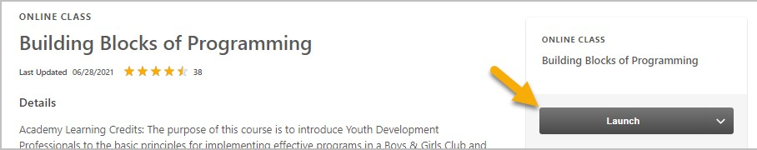
6. Your learning progress within the dev plan will automatically update to reflect your current status with the training. Your learning transcript will reflect the same status for the training.
7. Click Add a Comment to add a comment about an objective or about the overall plan, at any time. Each comment is limited to 5,000 characters. | 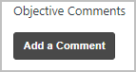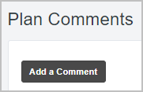
8. Click Upload Attachment to add supporting documents to your plan at any time. Your plan is limited to 25MB of attached items or 50 files. When one of these limits is reached, you cannot  attach anymore files. | 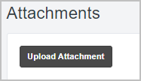

Competency Assessment Summary
Access Your Competency Assessment Summary at Any Time

1. You may wish to review your Competency Assessment Summary again at a later time. From the SLU Welcome page, click the menu icon, then Performance and click on the Competency Assessment Summary link from the drop-down menu that appears. | 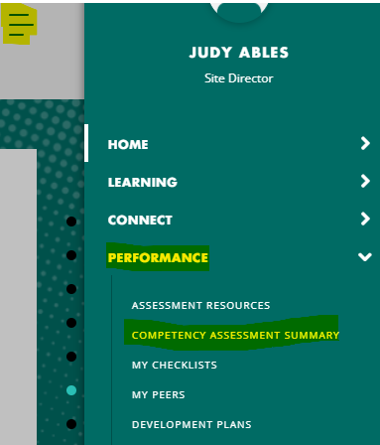
2. To view the assessment summary, click on the View icon | 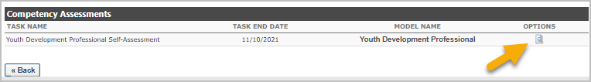
3. You are then directed to your Assessment Summary Page. You first see your average ratings by competency Factor (parent category). Click the green or red bar to drill down to the competency level. Drill down again to view individual item ratings.

4. Click on the View Assessment Report link to view and download the Individual Competency Ratings Analysis PDF.
5. Use the drop-down menu to view your competency strengths and development areas, and to view recommended development actions that are based on your average competency ratings. Recommended Actions can be selected and added to a development plan. | 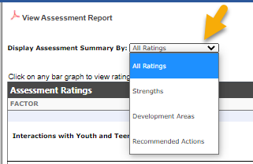

6. Choose ‘Recommended Actions’ from the drop-down menu and a menu of recommended development actions and training appears, grouped by competency. Click the checkbox next to items you wish to add to a development plan. If you previously created a plan from this screen, you can add additional items to it from here. | 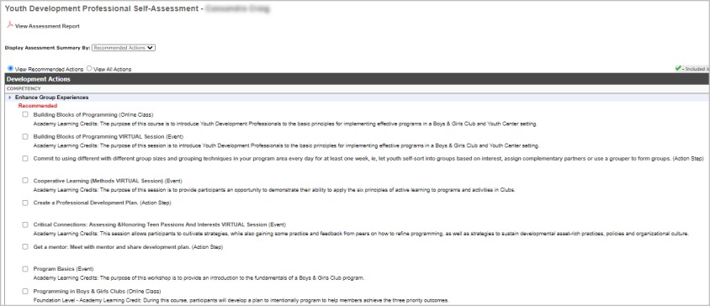
7. When you have selected all the recommendations you wish to add to your plan, scroll down to the bottom of the screen and click the Create Dev Plan button. This will instantly create a development plan for you or add the items to your existing plan. If you later wish to return to this screen and add additional recommendations to your plan, you may. Just follow the same steps. Click Done to exit the screen. | 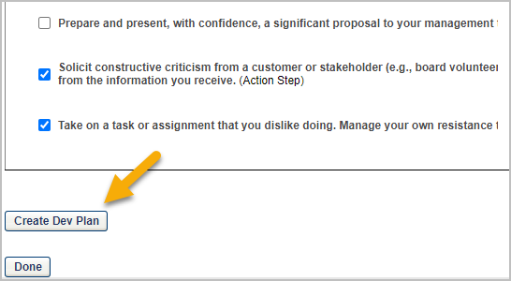

Development Plan
Editing Your Development Plan
1. After creating your development plan from the Competency Assessment Summary Recommended Development Actions, you may wish to make changes to it. Navigate to Performance > Development Plans via the main menu icon. | 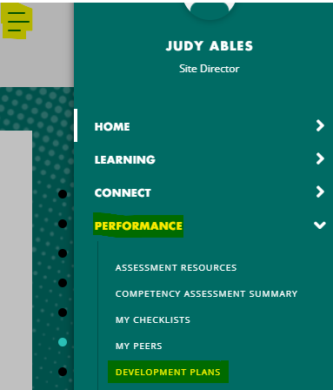
2. From the Development Plan screen, find your existing plan (the name will be the same as your competency task), and click Edit from the dropdown selector. | 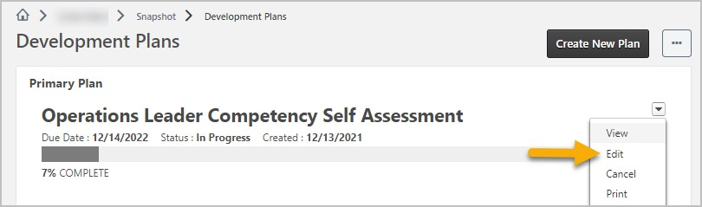

3. Your plan opens, showing instructions at the top. You may change the Plan Title if you wish. | 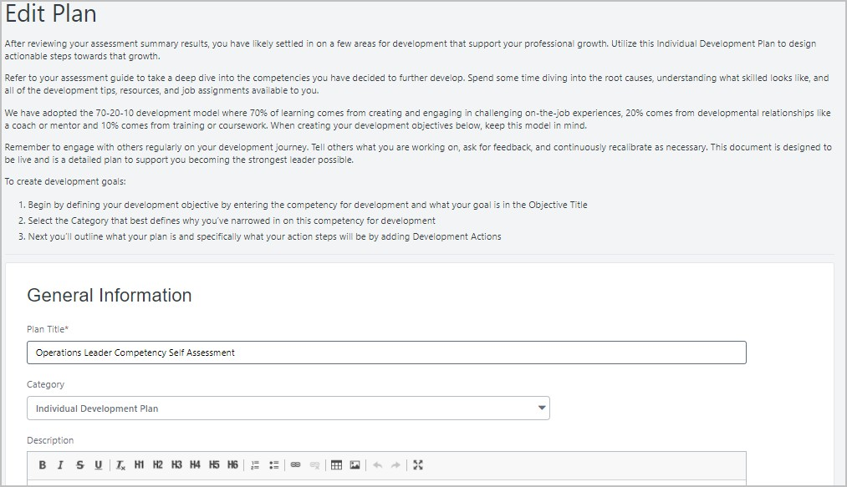
4. Further down the screen, one or more Development Objectives appear, and each will have one or more action items and/or training items. Click the Edit icon to the right of the objective title if you wish to add, edit, or remove items from that objective. You can also click the Add Objective button if you wish to add a new development objective. | 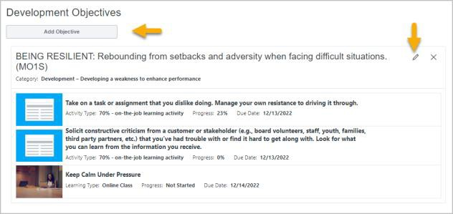
5. When editing an objective, there are multiple options. You can change the Objective Title, or change the objective Category via the drop- down selector. In addition to adding additional actions or training to the objective, you can change Due Dates for items, delete items and edit the details of Action Steps. Click the Pencil icon to edit an item. Click the X to delete an item. | 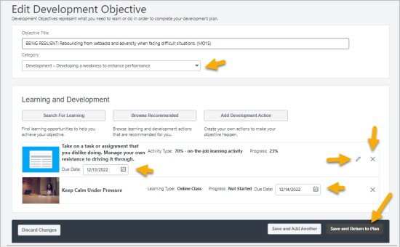
6. When editing a Development Action, you can change the Description, change the Activity Type via the drop-down selector, change the Due Date or update the progress percentage by entering a number between 0 and 100. Click Done to save changes and return to the Objective. | 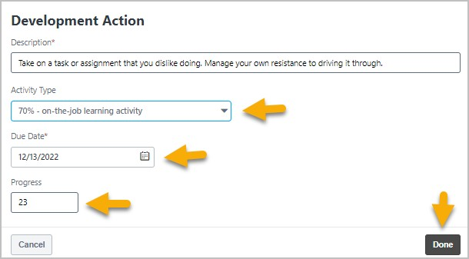
- There are three options for adding items to an Objective:  - Search for Learning (search for training by title or keyword)  - Browse Recommended (add recommended training from a past assessment)  - Add a Development Action of your own design (text entry) | 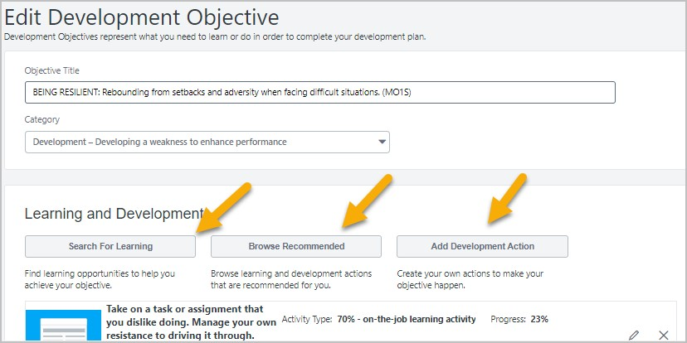

8. Click the Browse Recommended button to find and add development actions and training recommended from your competency assessment. (This is an alternative approach to adding recommended items from the Competency Assessment Summary screen.) | 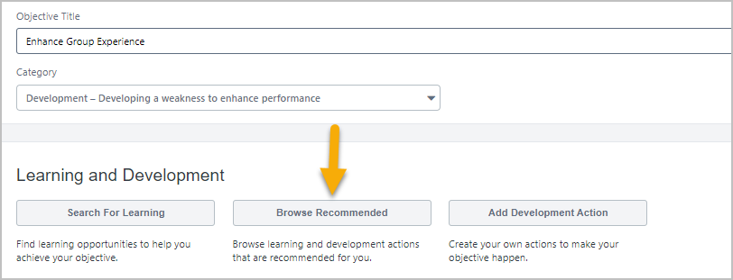
9. From the Recommended Learning & Development Actions screen, untick the Competency Model and Continue Learning checkboxes to limit choices to assessment recommendations. Scroll through the Youth Development Professional Self-Assessment carousel to find and add appropriate action items and/or training to your objective. Scroll the carousel to the right using the arrow to see more choices. Click Add to Objective to add an item to your plan. | 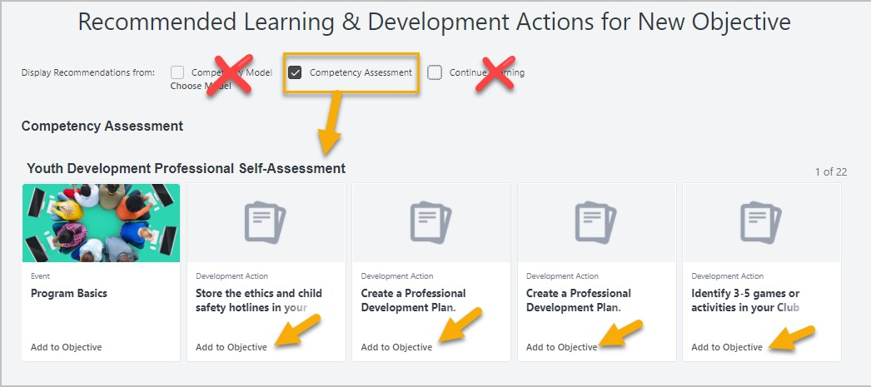
10. When finished adding items to your objective click the Return to Objective button at the bottom right of the screen. | 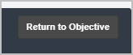
11. The items you add appear in the Learning and Development section of your objective. Adjust due dates as needed. Click the edit icon for action items if you want to adjust or add to the wording. If you are done adding objectives, click Save and Return to Plan. If you need to add another objective click Save and Add Another and repeat steps to define new objectives and add development and training to them. | 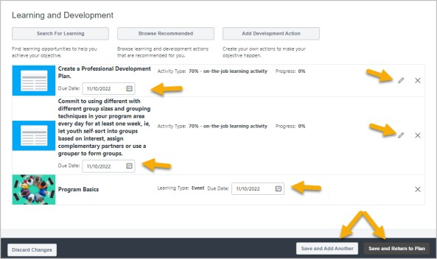
12. Note: If appropriate, you can also search for learning to add to your objective via key words, subject, etc., or add your own free form development actions. | 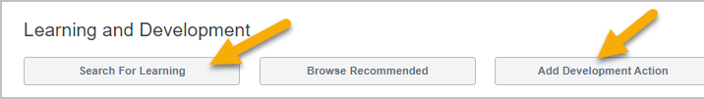
13. When adding your own Development Action, type a sentence that describes the action you will take, update the Activity Type and Due Date if needed and click Done. | 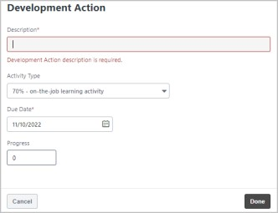

14. When Searching for Learning to add to an objective, you can search by keyword, and filter results by training type and/or subject. To add a training to your plan, click the Add to Objective link that appears below its title. When finished adding training, click Return to Objective at the bottom right of the screen. | 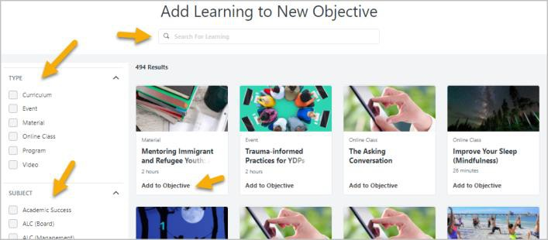
15. When finished editing your plan, click Submit Plan. The button reads ‘Submit’ rather than
‘Save’ because sometimes changes to plans need approval from a manager, etc., though that is not currently the case.
16. Your revised plan appears on the main Development Plan screen. Click on the plan name to view it and manage progress. Using the drop-down selector on the right, you can also edit, print, or cancel the plan, as needed. | 