Contents
Open Your Transcript 2
Multiple Views of Your Transcript 2
Search for a Training on Your Transcript 3
Withdraw from a Session 3
Navigating the Active View of Transcript 4
Review Completed Training and Print a Certificate of Completion 5
Add External Training 5
Mark External Training Complete 7
Export to PDF 8
Run a Transcript Report 8
Archived Training 13

This job aid details how to access, sort, filter and take action on learning items on your Transcript within Spillett Leadership University.

Open Your Transcript
From the Welcome page, click the My Transcript icon in the quick links section.
Alternately, click the My Training link in the widget in the upper left corner of the Welcome page. | 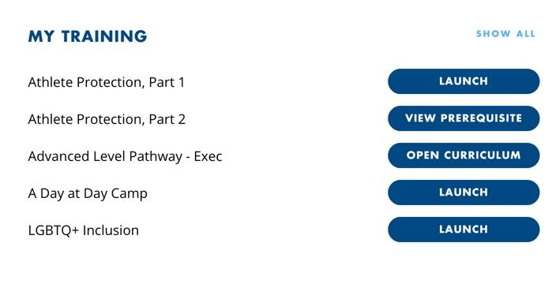

Multiple Views of Your Transcript
Your transcript defaults to a view of your Active training. Active training is all training that is not completed and not archived that either you requested or was assigned to you. | 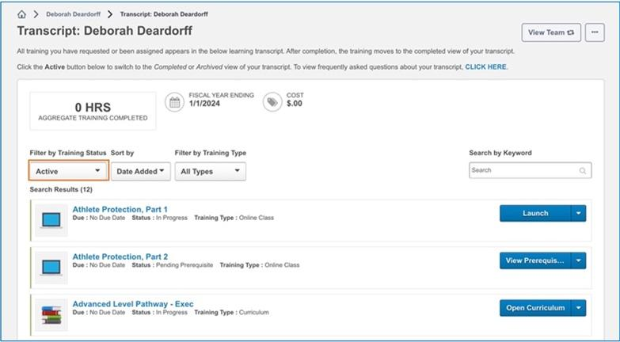
To view a list of completed trainings, select Completed from the Training Status filter drop down list. | 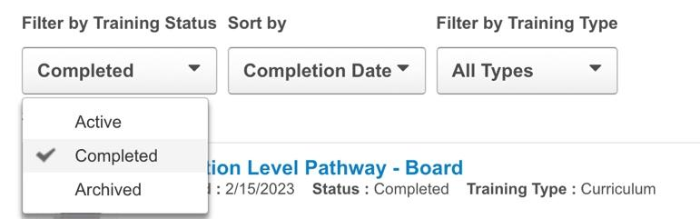
To find and view items that are archived, select Archived from the Training Status filter drop down list. Please keep in mind that archiving training does not remove responsibility for completing training that is assigned to you. | 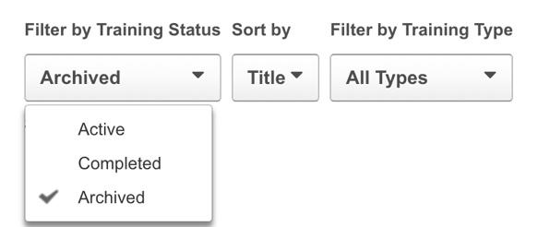

Search for a Training on Your Transcript
From any view of the transcript, use one or more of the following options to locate a training item on your transcript.
- Use the Sort by options to organize the results by Title, Status, Date Added, Training Type or Due Date.
- Use Filter by Training Type to limit results to Online Class, Video, Curriculum, Session or Material.
- Search by Keyword to narrow the list to results that match the criteria entered.

Withdraw from a Session
In general, it is faster to launch and take action on active training from the My Training widget or the Learning Pathway Player on the Welcome Page when you first log into SLU.

However, there are scenarios where using the Active Training Status view of the Transcript is necessary. For example, to withdraw from an instructor-led in person or virtual session that is not visible from the My Training widget,
- go to your Transcript
- click the drop-down arrow next to View Training for the session
- select Withdraw.

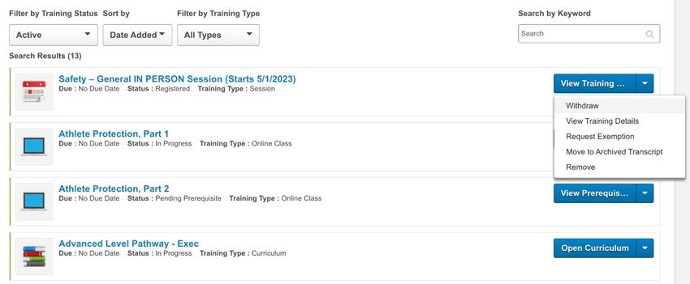

If the session is within a curriculum, open the curriculum and navigate to the session. Two examples are provided below.
In the Club Directors Orientation Program curriculum, from your transcript,  - click Open Curriculum  - click Getting Started Section Tab on the left  - click the drop-down arrow next to Launch  - select Withdraw  - select a Reason and click Submit | In the First Time Supervisor Program curriculum, from your transcript,  - click Open Curriculum  - click Workshop Session Section Tab on the left  - click the drop-down arrow next to Launch  - select Withdraw  - select a Reason and click Submit

Navigating the Active View of Transcript
The blue button to the right of each training item lists the next logical action. There are options available in the drop-down menu that vary by Training Type (i.e. Online Class, Material, Event) and Status (In Progress, Pending Prerequisite, Pending Evaluation). Some examples include:
- Launch for an In Progress Online Class
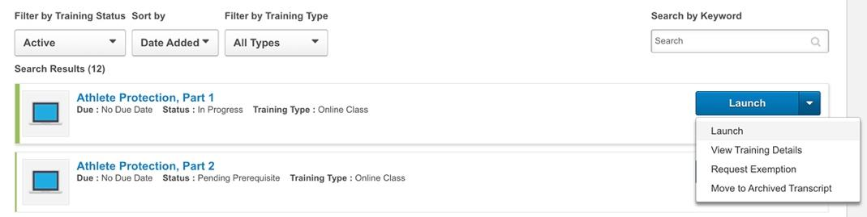
- Mark Complete for an In Progress Material
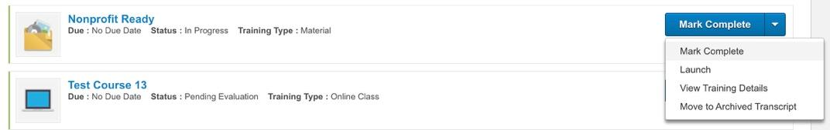
- View Prerequisite for any training that requires the completion of another training before it can be opened
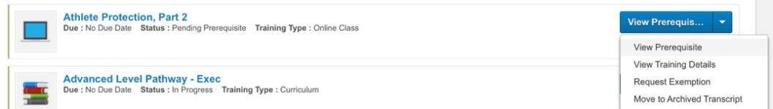

Review Completed Training and Print a Certificate of Completion
With the Training Status filter set to Completed, you can
  - view and print a Certificate of Completion
  - open or launch the training to review it
  - view details about the training
  - archive the training which moves it to a different view of your transcript but doesn’t change your completed status or ability to access it or print certificates
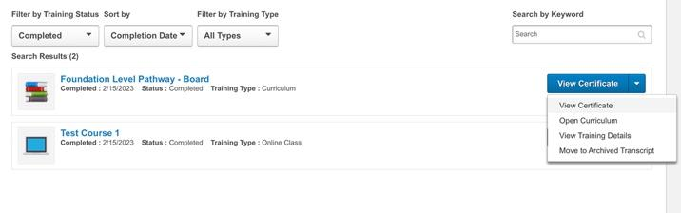

Add External Training
At times, you may need or want your SLU learning transcript to include training that you completed outside the system, such as an external seminar or program. External training is a tool that allows you to add miscellaneous outside training to your SLU transcript. If the training already exists in the SLU training catalog, you should not add it as external training. This job aid will walk you through the steps to add external training to your SLU transcript, and to mark it complete.
From your Transcript screen, click the options button (...) and then click Add External Training from the dropdown menu | 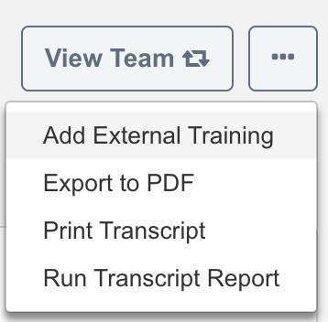
The Add External Training form opens. Read the on-screen instructions and take note that all fields are required, including upload of your proof of completion document. You should not attempt to add external training until you have completed it and have a certificate or other completion evidence that can be attached via upload. | 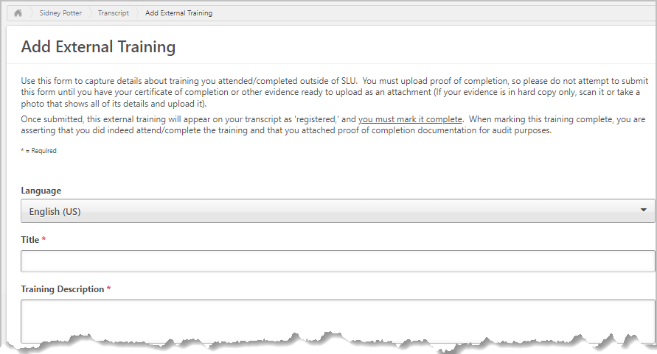

The Fields: What to Enter:  Title –The official name of the external training course.  Training Description – If possible, copy and paste description from the provider’s website, otherwise type in an approximation.  Institution/Provider of Training – Name of the organization that provides the training  Dates Attended – The start date and end date of your training.  Training Hours – Total hours of training  BGCA training requirements – If training meets requirements of one of the listed BGCA programs, check the box that applies; otherwise check N/A  Attach Proof of Completion – Scan and upload a copy of your certificate of completion or other evidence of completion. | 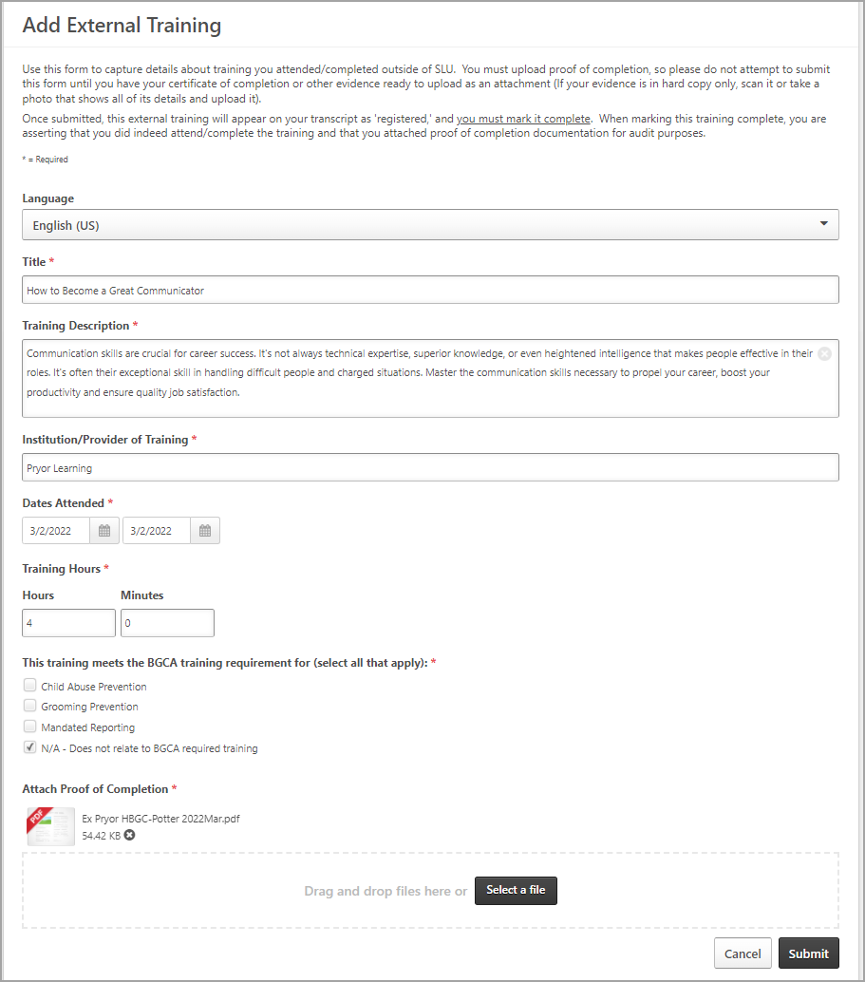
Click the Submit button to save the External Training to your transcript. | 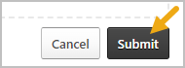

Mark External Training Complete
Find the external training on your SLU Transcript screen and click the Mark Complete button to its right. | 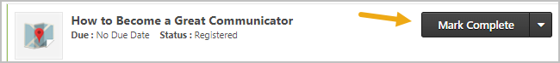
You may also review details and your certificate of completion by clicking View Training Details | 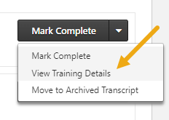
The external training now appears on your transcript Completed screen. You may review its details at any time by clicking View Training Details | 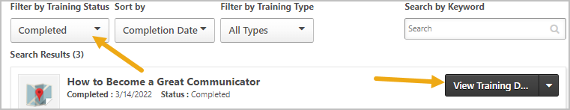

Export to PDF
To print the current view of the transcript page to PDF, from your Transcript screen, click the options button (...) and then click Export to PDF from the dropdown menu
Only the training that is currently displayed is included in the printed transcript. If there are multiple pages, then only the current page is printed. The PDF file name is "[User First Name] [User Last Name] - Transcript - MM/DD/YYYY."

Run a Transcript Report
Click on (…) icon on the top right to access the dropdown menu. And click on “Run Transcript Report”

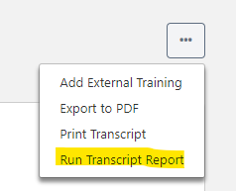

You will be brought to the screen below where you can select the criteria for your report.
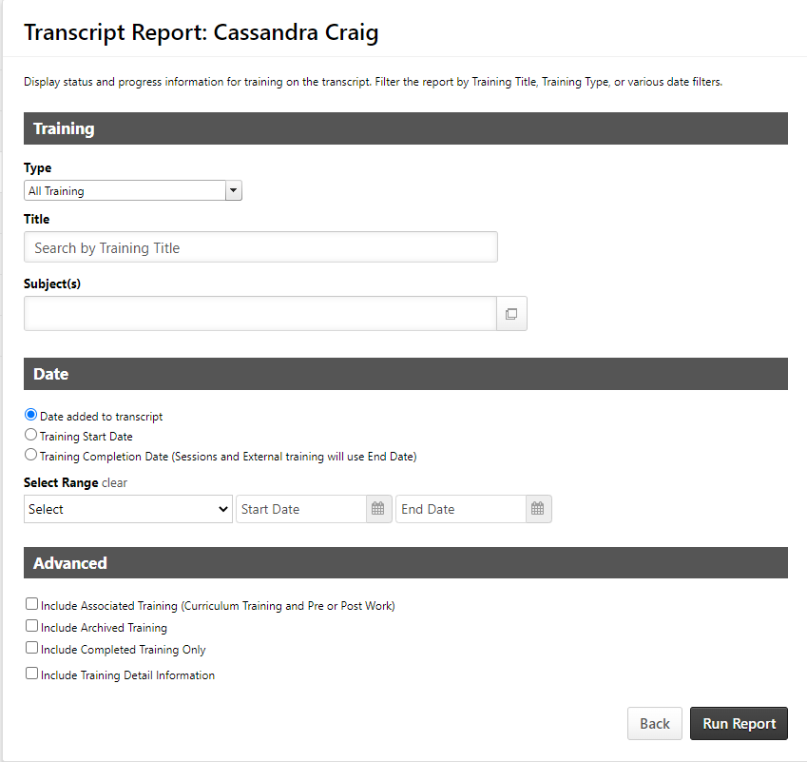

Under “Training” you have the option to select the training type, title or subjects you want displayed on your report. You can select as many as you want, but to get a full transcript report, it is suggested that you select all training types. For this training we will only run the report by training type.

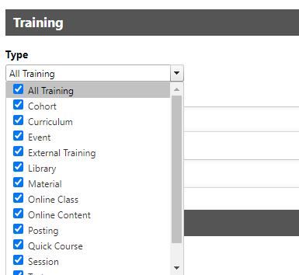

To get a full report of all completed training, under the “Date” tab, click on the option “Training Completion Date (Sessions and External training will use End Date)”

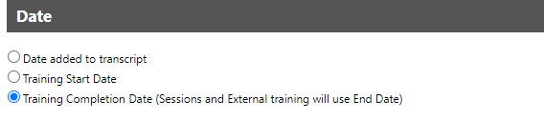

Next, select a date range from the drop down menu.

Or you can enter a date range manually by clicking on the calendar icon next to the start date and end date.

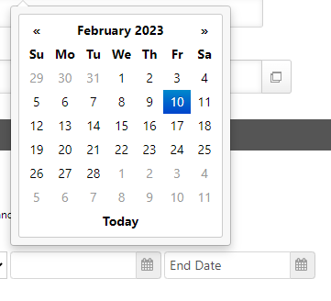

Under the “Advanced” tab you will select further criteria to add to your report. To run the most accurate report that reflects your course completions and includes archived trainings, pre and post work, and the completion of each instance of a training we will select the criteria below and then click “Run Report”:
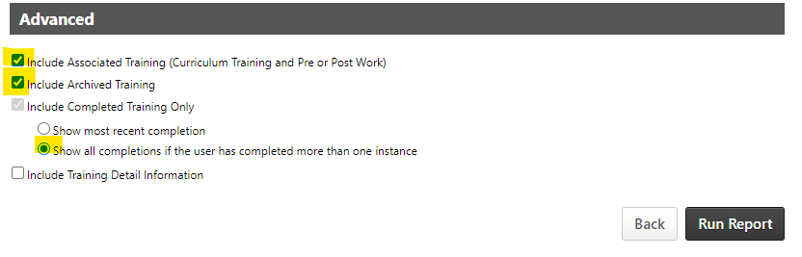

Your report will be exported as an Excel workbook.

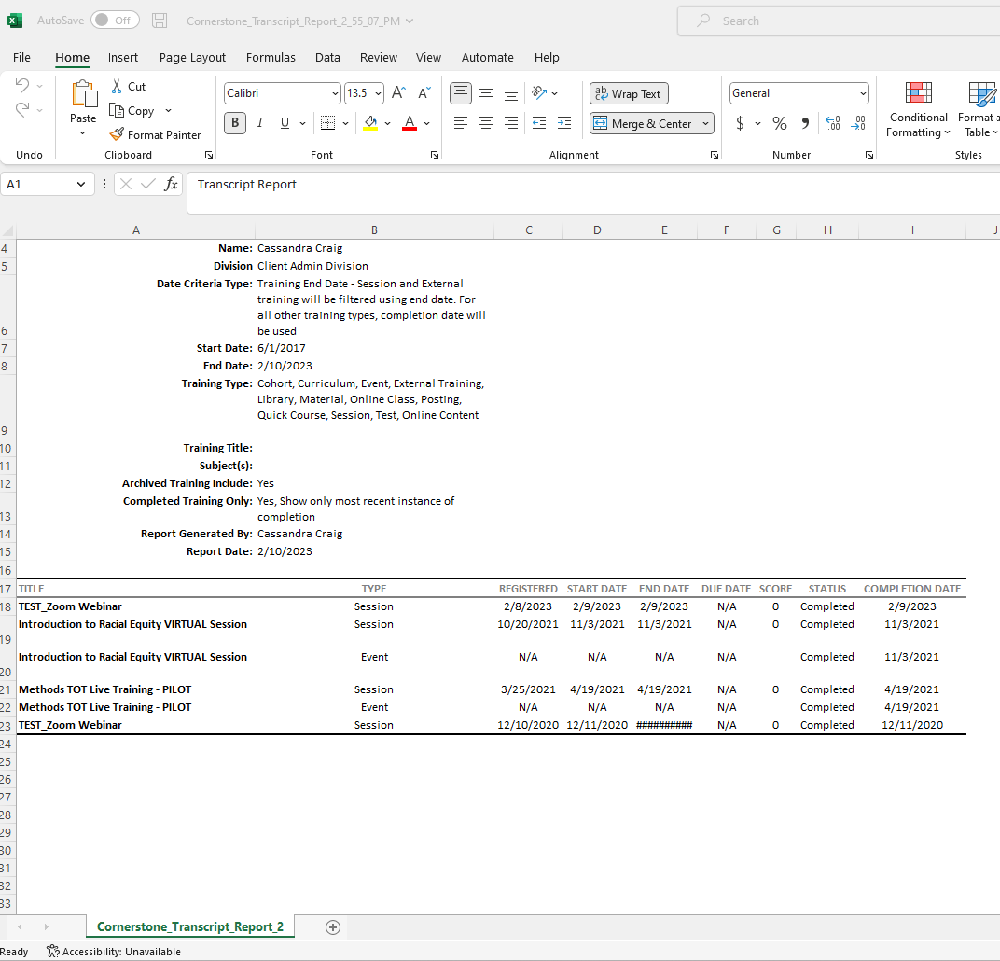

To run a report of your FULL transcript (including completed, in progress, registered, etc.) you will follow the steps above, but the criteria will be as follows:
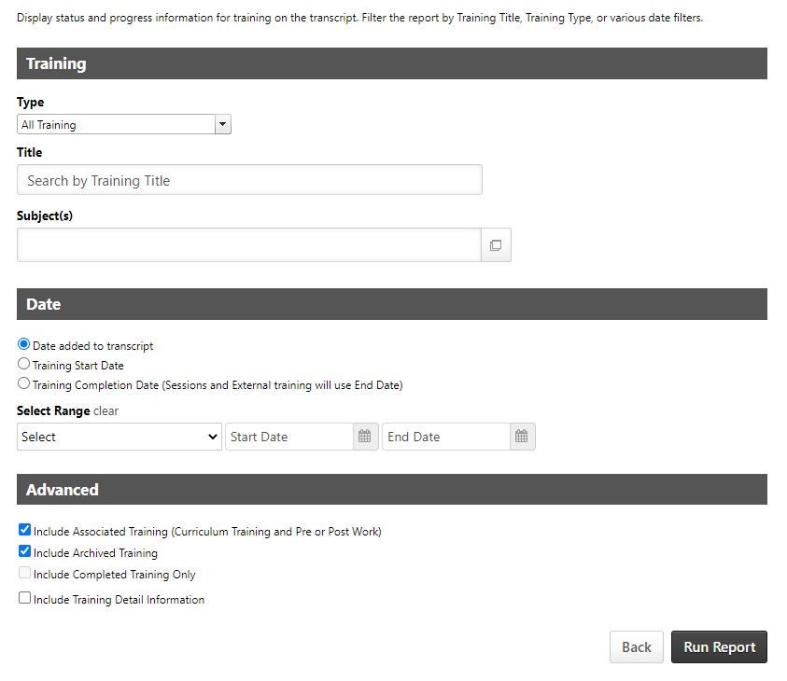

Then click “Run Report”.

Archived Training
The purpose of the Archive Transcript is to store training that the user no longer needs to access. Training is sometimes moved to the Archived view automatically when a training item is made inactive by an admin. You can also move items to your archived view if they are no longer relevant.

The act of moving training to Archived does not remove any responsibility you have in completing this training.

With the Training Status filter set to Archived you can
- Select Restore from Archived Transcript to put it back in the Active or Completed view depending on where it was when it was archived.
- View more information about the training by clicking View Training Details
- Open the content if the training is not Inactive

