Overview
The new role of Host Training Facility Owner has been created in SLU to allow one person from each club facility to create and manage host training facilities used for scheduling local training sessions, schedule and manage local training sessions in SLU, and to nominate one or more delegates to serve as Host Administrators. Approval from your CEO is required to become the Training Facility Owner (TFO) for your club, so we recommend discussing it with your CEO before applying. The Training Facility Owner Request form is available in SLU and must be submitted and approved to begin the process of qualifying for this role. Once submitted, the form must be approved by your CEO and BGCA. Upon final approval, the TFO curriculum will be added to your SLU transcript within 24 hours. After completing the curriculum, the TFO security permissions will be assigned to you within 24 hours.

Accessing the Training Facility Owner Request Form
- Log in to MyBGCA.net then click on the Spillett Leadership University icon to access SLU
- From the Home page, type ‘facility’ in the search field that appears in the top right corner of the portal and press ‘Enter.’

- From the initial Global Search results screen, click ‘Forms’ in the sidebar menu to the left to further filter the search results.
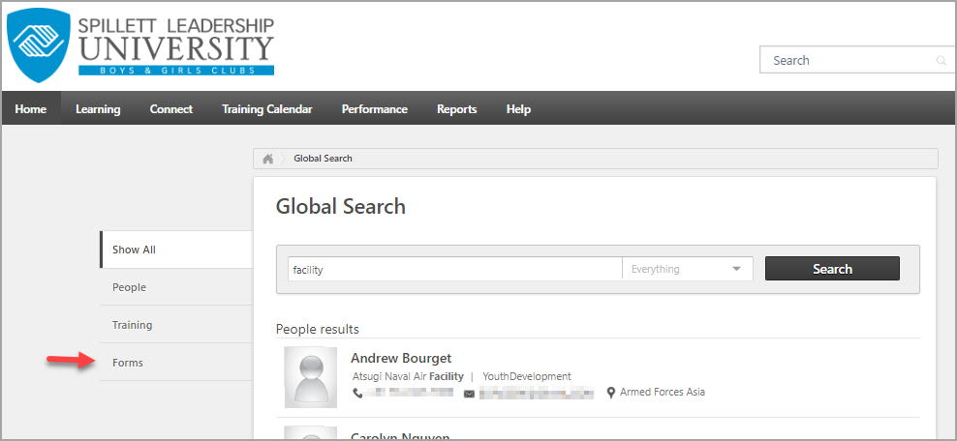

- The Training Facility Owner Request form now appears in your search results. Click on the form name to launch and complete the form.
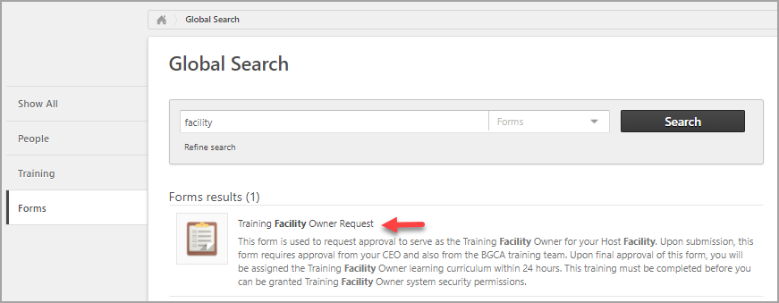

- The form opens. Read through all of the content of the form before completing its required fields and clicking submit. In order to serve as a TFO you must acknowledge and agree to adhere to BGCA guidelines and requirements for the role.
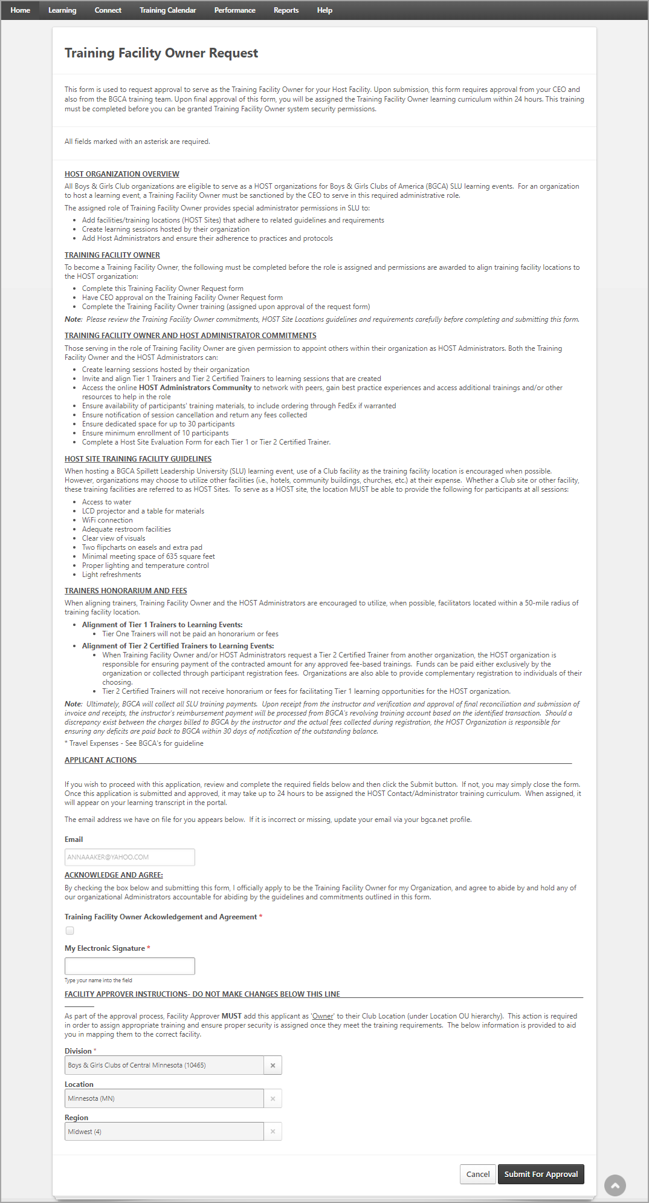

- If after reading through the details you still wish to proceed, click to check the Acknowledgement and Agreement box, type your full name into the Electronic Signature field, and click the Submit for Approval button at the bottom of the form. Do NOT attempt to change any information in the Facility Approver Instructions section. If you do not wish to proceed, just click the Cancel button at the bottom to close the form without submitting.
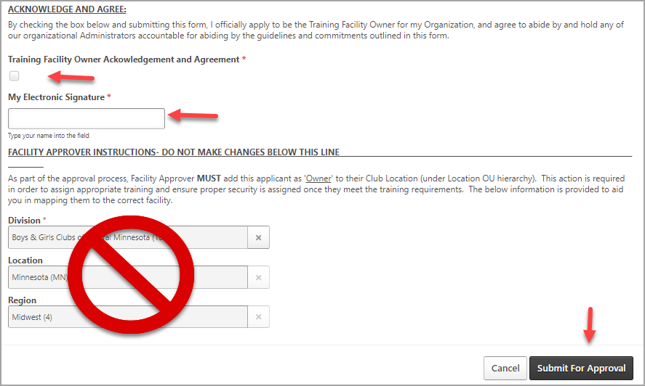

- Once submitted, you simply wait for form approval from your CEO and BGCA. Once those approvals are received, you will be assigned the Training Facility Owner curriculum on your SLU transcript and must complete that curriculum before you are granted TFO permissions.

Viewing Your Completed Form
You may review your completed form at any time by navigating to your Universal Profile Snapshot Documents:

- Click your Universal Profile icon in the top left corner of the portal
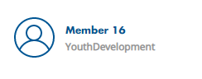

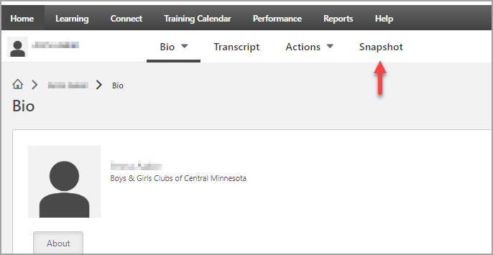
- From your Universal Profile screen, click ‘Snapshot.’

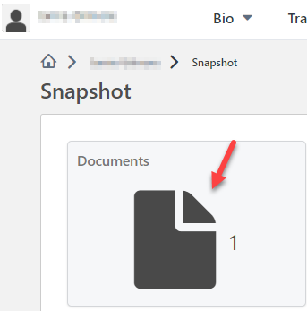
- On the Snapshot screen a ‘Documents’ widget appears, showing a count of your documents. Click the widget to view your documents.

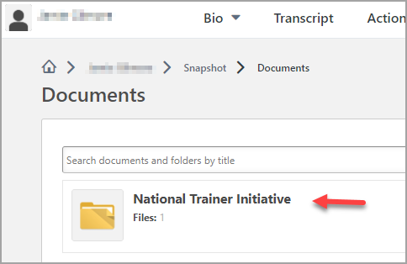
- Your completed form will appear within the folder titled National Trainer Initiative. Click on that folder title to view your form.

- All forms within the folder appear. Click on the name of the form to view it.

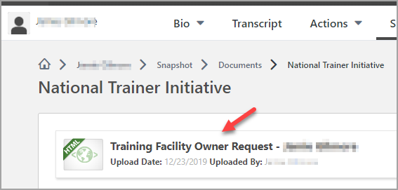
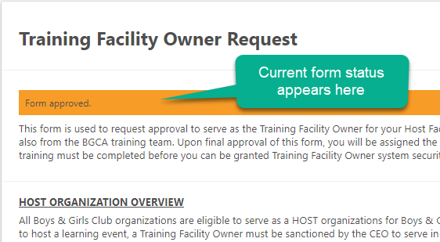
The form opens, showing all the information you submitted. At the top a colored status bar lets you know the current status for your form.

