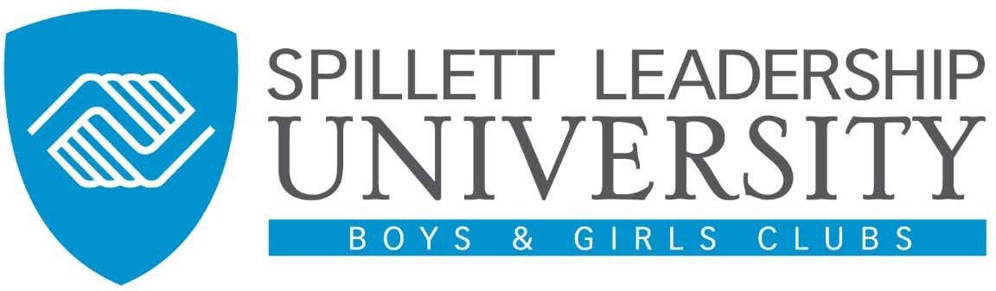

Frequently Asked Questions

Spillett Leadership University Catalog Offerings
- What types of training are available through Spillett Leadership University?

Via the “Browse for Training” menu option, you find any content that is visible to you either based on your Professional Category or a particular audience. Each training will have one of the following Type icons:

Online Courses Web-based training available 24hrs a day 7 days a
week. Used as a standalone training mechanism, as part of a blended training solution or in a curriculum.
Videos Learners can register and watch videos and or video based training and have their completion noted on their transcript.

Events & Sessions (Instructor Led Training)
In person or virtually (i.e. webinar) led live training sessions. Sessions may be single day,multi day or multi part.

Material Registration link to a variety of informal learning resources: (i.e. Website, Recording, Audio, PDF or Word Documents, Books, etc…)
Curriculum A series of training that could include one or more types of training of learning objects and are bundled. A curriculum can include tests, external training, online courses, events, postings, and materials.
Library Bundle of online classes packaged together in one central searchable repository.

Programs & Cohorts Combination of a training and community based
collaborative learning experience. Participants register for a cohort and have their training tracked based on a dedicated start and end date.
Tests A learning object that serves to measure a user’s knowledge and understanding of a particular topic.”

- How much does training on Spillett Leadership University cost?
Currently cost implications are aligned to Instructor Led Training. For each of these events, once you click on the event link it will show you details related to the event and any cost implications. Currently, all online courses, materials and or video based trainings are made available to you free of charge.

