Contents
View an Individual’s User Record and Transcript 2
Search for Individual 2
View Transcript 3
Transcript Status Report 5
Accessing the Report 6
Generating the Report 7
Enterprise Training Report 9
Accessing the Report 9
Generating the Report 10
Training Progress Summary Pie Chart Report 11
Generating the Report 13
Security Role Administration 14
Adding & Removing the Org Admin Permission 14
Bulk Participation Enrollment of Fee Based Instructor-Led (ILT) Training Sessions 16
Purchasing Session Seats for Others 16
Assigning Your Inventory Seats 18
Inventory Management FAQs 21
Reviewing and Printing Previous Transactions in SLU 22
Substituting One Learner for Another on Session Rosters 23
Performing a Session Substitution 23

View an Individual’s User Record and Transcript
The following section provides the steps necessary to select an individual and view their User Record, Transcript and view progress or completion of training and curricula within Spillett Leadership University.

Search for Individual
These instructions provide guidance for locating a staff member and viewing their User Record.

- From the Welcome page, click Manage Users on the Quick Links Toolbar.
- OR, you can also access from the Navigation menu by clicking the icon at the top right (SEE BELOW)  - Then click on Users. | 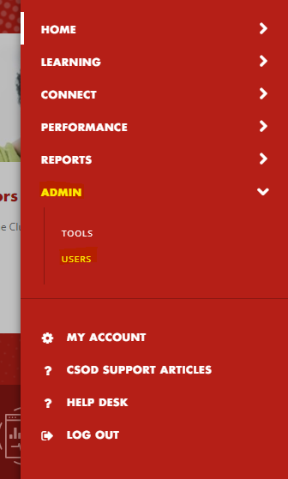
NOTE: You may also search for users by entering their first or last name in the global Search bar.
- On the Users page, type in the last and/or first name and click on the Search button. You can view all staff by leaving all fields blank and clicking on the Search button. | 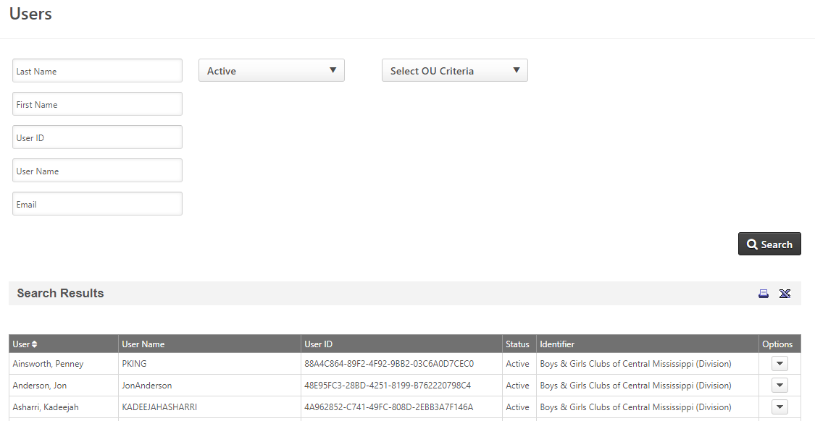
- Locate and select the desired user by clicking on the name to view the individual’s User Record.  This page displays the selected individual’s bio where the following information is presented:  - Name  - User Name  - Email  - BGC Organization  - BGC Org Site  - Position/School Affiliation  - Region  - Additional Custom Information | 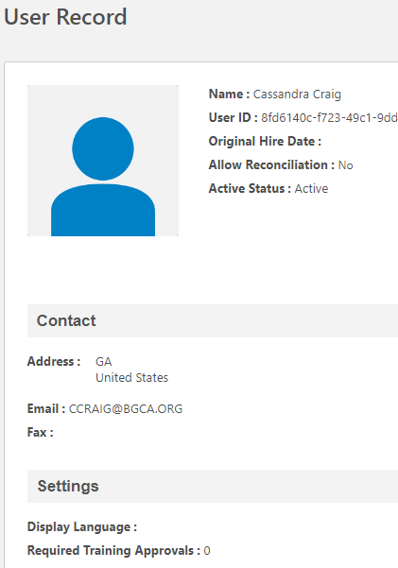

View Transcript
Training in Progress
- To view a user’s transcript from the Users admin page, locate the individual and using the drop down arrow, click on View Transcript.

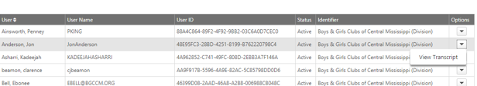
NOTE: You may also access their transcript by clicking on Transcript from the top menu of the individual’s User Record.
- The Transcript page is presented displaying the aggregate time spent in training for the fiscal period listed.  Below, the transcript lists the Active training (currently in progress) by default. | 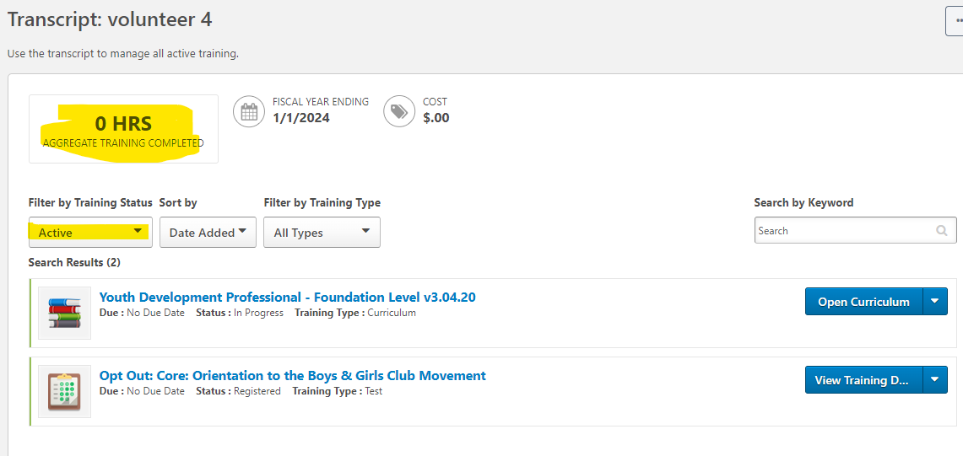
- To view the individual’s progress through the curriculum player, click Open Curriculum.
- The curriculum player is presented allowing you to explore the content and view the individual’s progress by opening and accessing the details within any section of the curriculum.  Click to expand sections within the curriculum. | 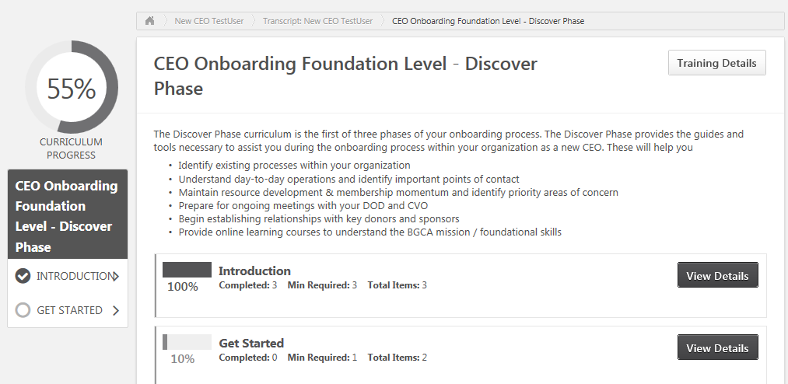  Click View Details to open and view the individual’s progress within the section
Checkmarks appear for completed items within the curriculum. | 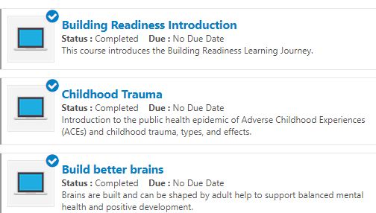
- To view all items within a curriculum and the individual’s progress click on the Options dropdown menu at the top of the curriculum player window and then select View Training Details.

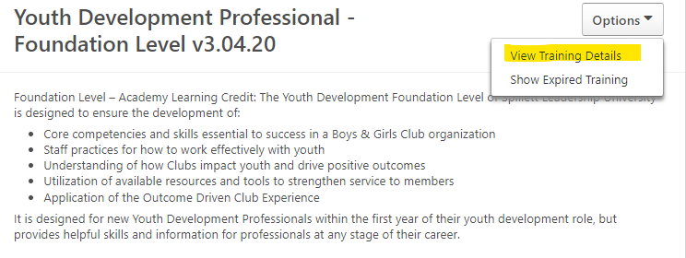
- The Training Details list appears allowing you to scroll through the items within the curriculum to view the individual’s progress.  - To return to the previous screen click the  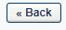button located at the bottom of the page. | 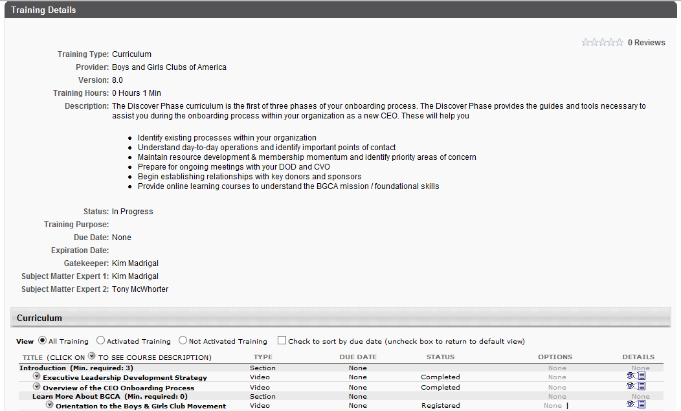
Completed Training  - From the selected individual’s Transcript view, click the dropdown and select Completed.  The transcript is updated presenting the listing of any training completed by the selected individual. | 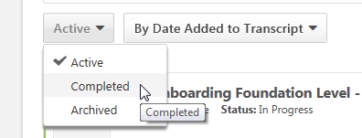
- To view the details of completed items click the View Training Details button next to the desired training or curricula OR the learning object’s name.

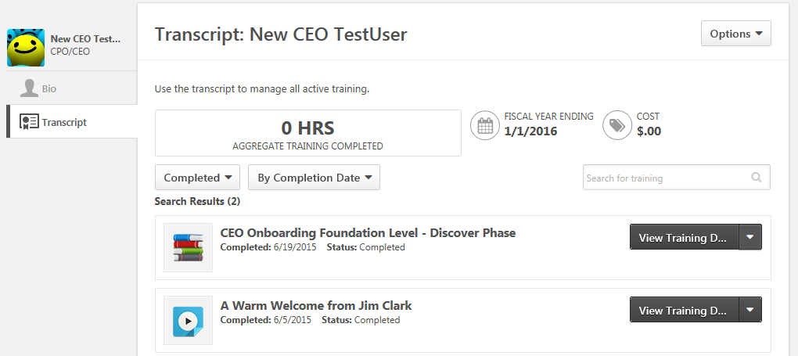

Transcript Status Report
These instructions provide guidance for locating and accessing the Transcript Report allowing you to generate, view and export a report of individuals and their progress through training and/or curricula in Spillett Leadership University.

Accessing the Report
- From the Welcome page, click Standard Reports on the Quick Links Toolbar.
- OR you can also access from the Navigation menu by clicking the icon at the top right (SEE BELOW). | 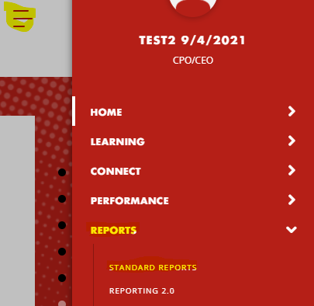
- Click on the Training button at the top of the page. Scroll down and select the Transcript Status Report. | 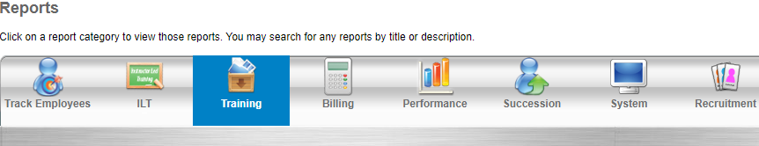  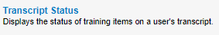
- The Transcript Status Report page is presented enabling you to select the criteria and generate the desired transcript report.
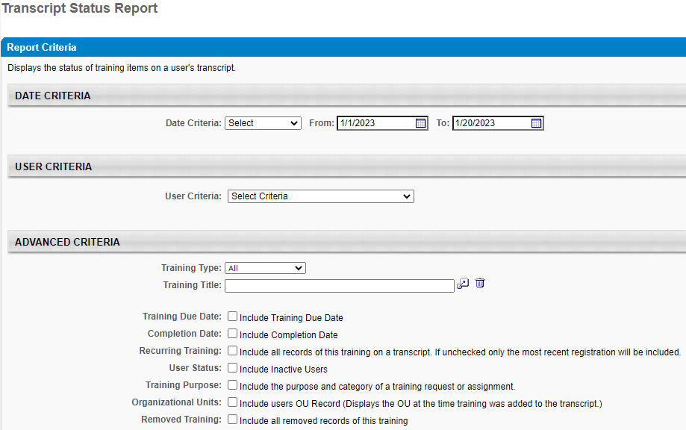

Generating the Report
- DATE CRITERIA – enter a date range or select an option within the dropdown (e.g. “This Year”).
This filter your results based on when learning objects were added to a user’s transcript, so you may want to adjust your date back a year to capture all offerings.
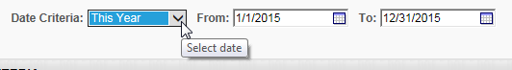
- USER CRITERIA defaults to all users within your organization. To search all users within your organization, proceed to step #10.  To search by user, select “Users” in the dropdown and follow instructions, and proceed to next step. | 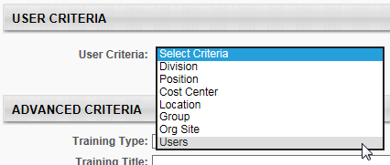
- Click the selection icon
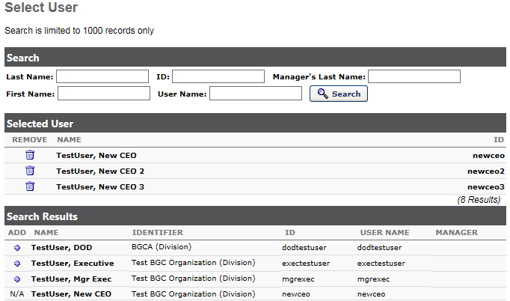
- Enter the search criteria in the Select User window for the individuals you want to include in the report and click Search

- From the search result click the icon next to each individual you would like to include in the report.

NOTE: You may continue the search and selection process until you have selected all desired individuals.
- Once the selection process is complete click the DONE button at the bottom of the Select User window.  NOTE: Selecting CLOSE will result in LOSS of selections and you will need to repeat the process. | 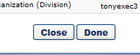
- Select from the list of filters, as shown below. To track annual Safety compliance training, please be sure to select the option to include ‘Recurring Training.’
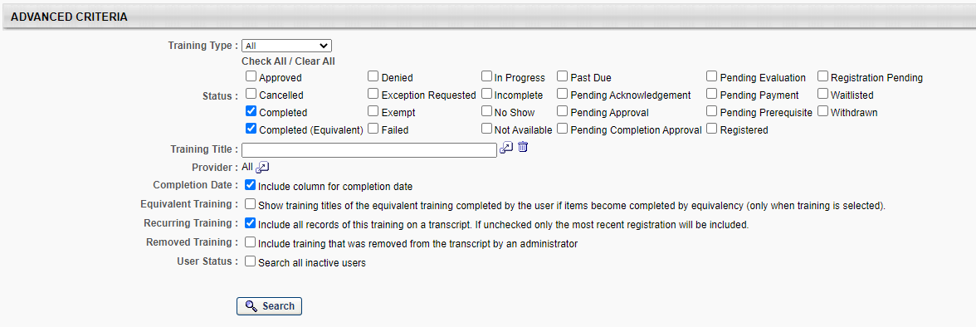
- PROCESS REPORT - scroll to the bottom of the screen to the Process Report section and enter a name for your report in the Report Title textbox

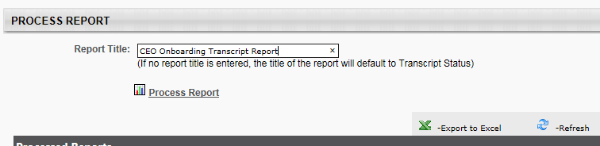

- Click Process Report.
- The page refreshes and the report is queued for processing.
NOTE: It may take 2-3 minutes to process the report.
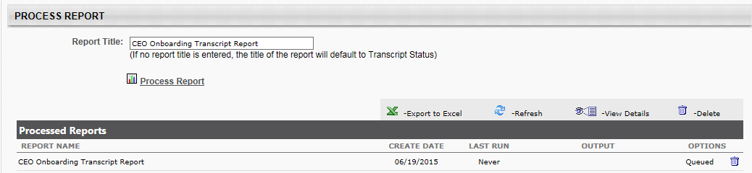
- You may continue to navigate through Spillett Leadership University while the report processes.
- After waiting a couple of minutes either return to the Transcript Status Report page from the landing page, or if you remained on the same page simply refresh your browser screen.
- Once processed, the report will provide an option to export the report to Excel so you may view or save it locally.

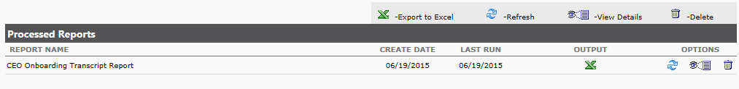

- Click the icon to open the report in Excel.

NOTE: Once created, you may return and rerun the report at any time, simply click the button to refresh with the latest data and once processed export to Excel.

Enterprise Training Report
These instructions provide guidance for locating and accessing the Enterprise Training Report allowing you to generate, view and export a report of individuals and their progress through training in Spillett Leadership University.

Accessing the Report
- From the Welcome page, click Standard Reports on the Quick Links Toolbar.
- OR you can also access from the Navigation menu by clicking the icon at the top right.
- Click on the Training button at the top of the page. Scroll down and select the Enterprise Training Report. | 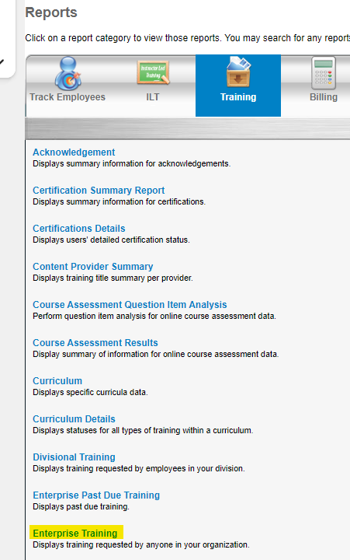
- The Enterprise Training Report page is presented enabling you to select the criteria and generate the desired training report.
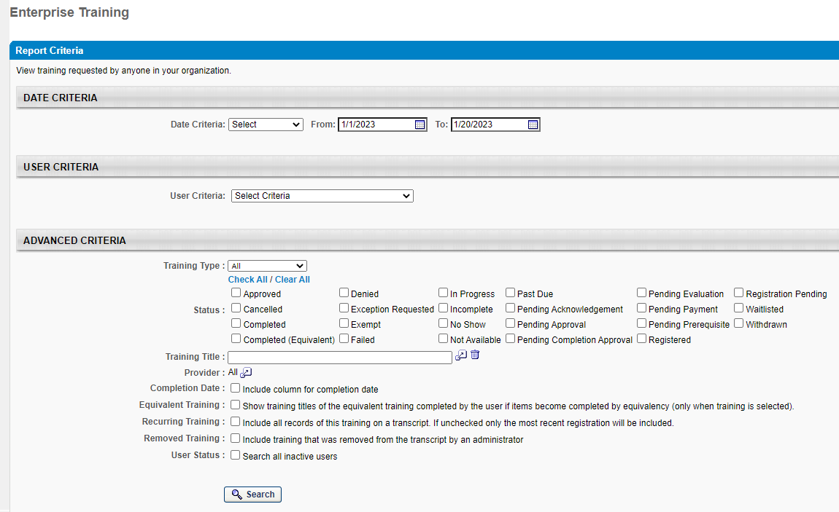

Generating the Report
- DATE CRITERIA – This date field corresponds to the Registration Date of the training(s), which may span over time, for example a learner may have completed the training in 2022, but registered for the training in 2021. Enter a date range or select an option within the dropdown (e.g. “This Year”).
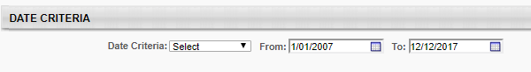
- USER CRITERIA – enter your user criteria. If not selected, it will generate all user records for the desired training. User Criteria options are as follows:  - Division = BGC Organization  - Position = Professional Category/School Affiliation  - Cost Center = N/A  - Location = Region  - Org Site = BGC Org Site  - Users = Active SLU Users | 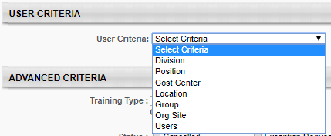
Please note that the system automatically defaults to your organization. In this example, we will pull all records for your organization. | 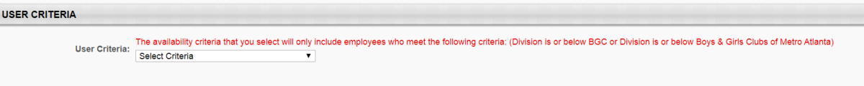
7. In the Advanced Criteria, you can filter your report by Training Type, Status and Training Title.  Important Note: Please be sure to select the User Status to include all inactive users. | 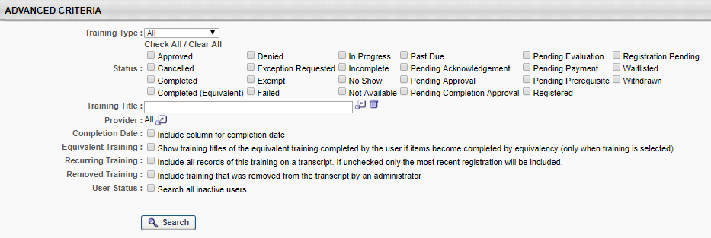
In this example, check the status of all Metro Atlanta users enrolled in the Youth Development Foundation Level curriculum.  8. Once all options have been selected, click Search. | 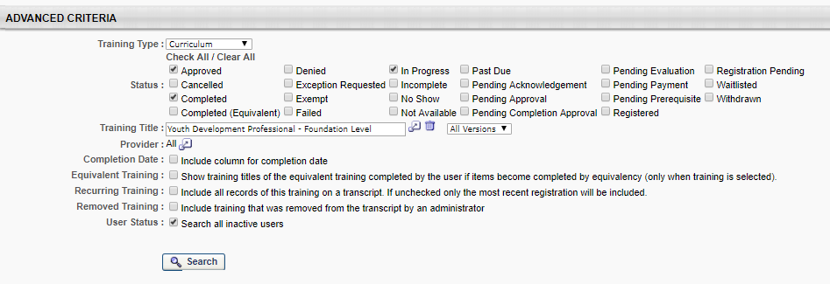
9. It will then display the results of the report. | 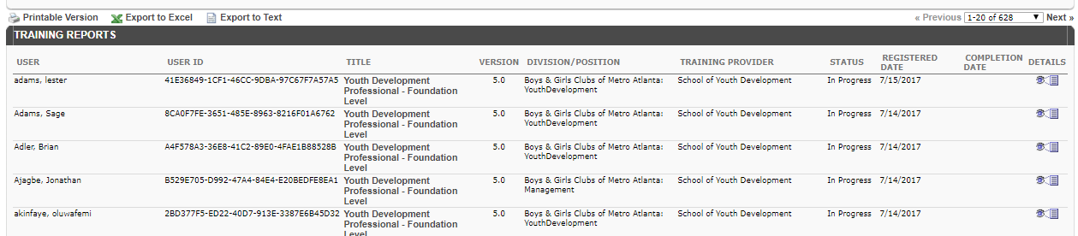
10. To print or export the report, click on the options provided.

Training Progress Summary Pie Chart Report
These instructions provide guidance for locating and accessing the Training Progress Summary Report allowing you to generate, view and export a pie chart summary of users’ progress for a specific training item.

Accessing the Report
- From the Welcome page, click Standard Reports on the Quick Links Toolbar.
- OR you can also access from the Navigation menu by clicking the icon at the top right.
- Click on the Training button at the top of the page. Scroll down and select the Training Progress Summary Pie Chart Report. | 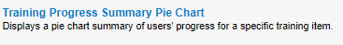
- The Training Progress Summary Pie Chart Report page is presented enabling you to select the criteria and generate the desired transcript report.

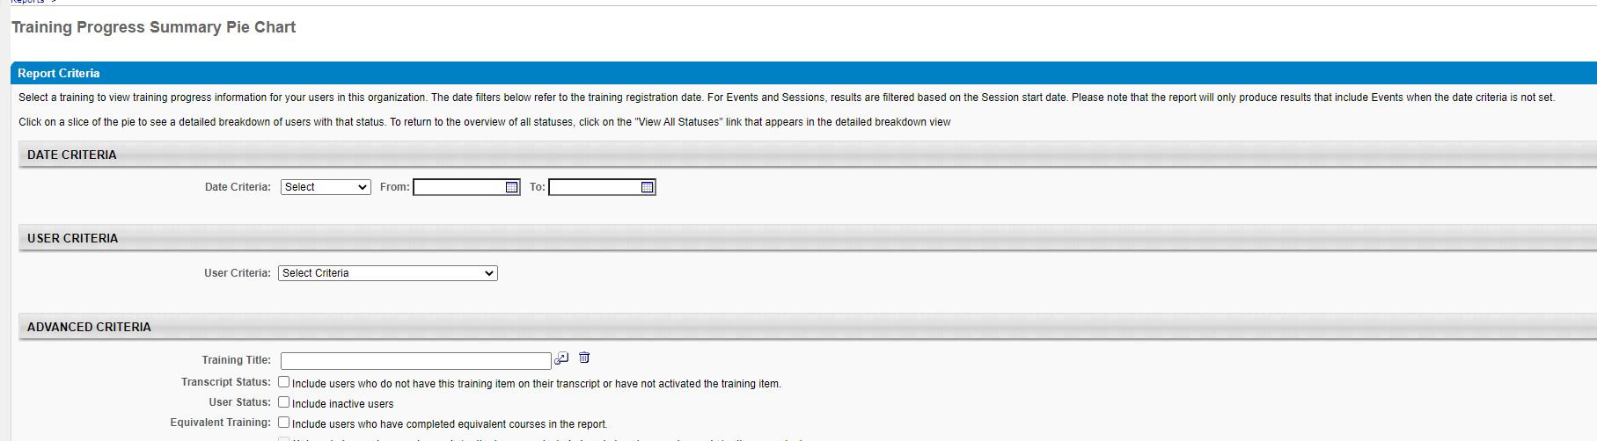

Generating the Report
- DATE CRITERIA – enter a date range or select an option within the dropdown. If not selected, it will generate all records for the desired user(s).
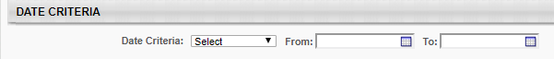
- USER CRITERIA – enter your user criteria. If not selected, it will generate all user records for the desired training. User Criteria options are as follows:  - Division = BGC Organization  - Position = Professional Category/School Affiliation  - Cost Center = N/A  - Location = Region  - Org Site = BGC Org Site  - Users = Active SLU Users | 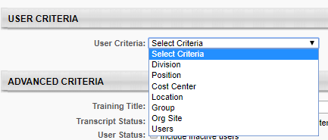
- If no selection is made, it will generate all records for all users associated with the desired training. | 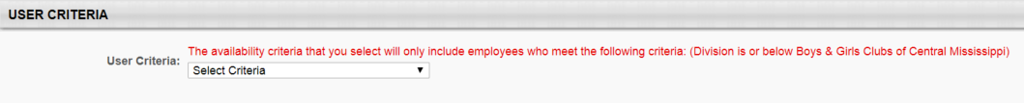
- Once the selection process is complete click the DONE button at the bottom of the Select User window.  NOTE: Selecting CLOSE will result in LOSS of selections and you will need to repeat the process. | 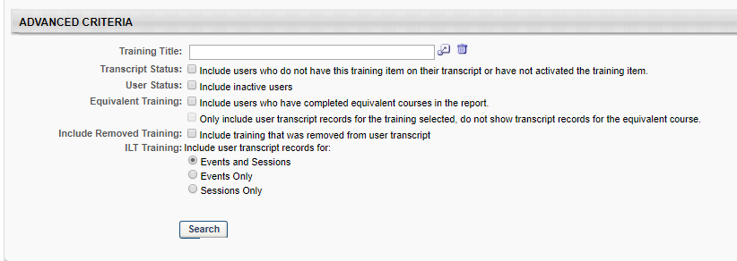
In this example, let’s see a visual display of users’ progress within the “Core: An Orientation to the Boys & Girls Club Movement” online class.
- Click the selection icon for Training Title.
- Deselect all training types, except for the Online Class training type and type “Orientation” in the search box.  - Click Search. | 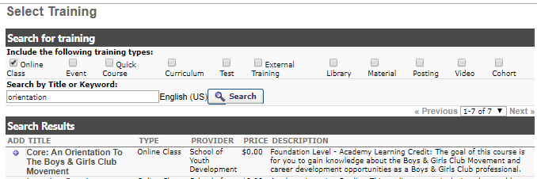
- Click the icon to make your selection. | 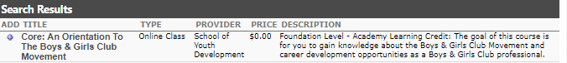
- Be sure to include the option to “Include inactive users.”  - Click Search. | 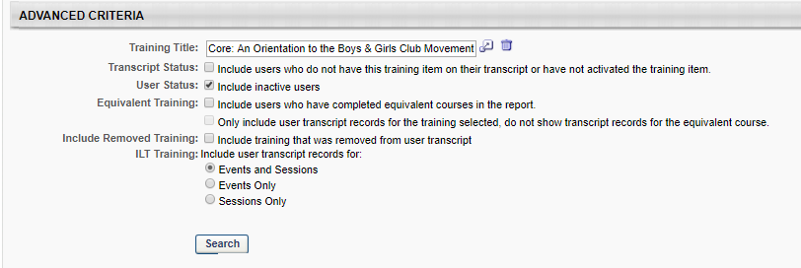
- It will then display the results of your report. | 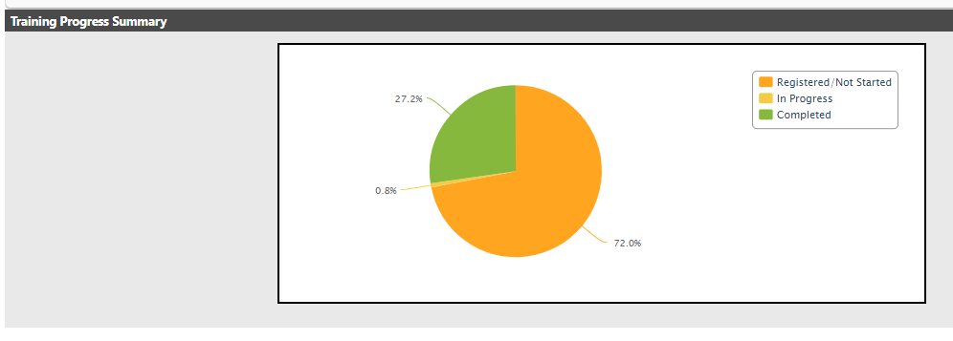
- To print or export the report, click on the options provided.

Security Role Administration
The following section provides the steps necessary to add the Org Admin role to other users within your organization.

Adding & Removing the Org Admin Permission
- From the Welcome page, click Manage Users on the Quick Links Toolbar.
- OR you can also access from the Navigation menu by clicking the icon at the top right. Click Admin on the main toolbar by clicking the icon at the top right  - Then click on Users. | 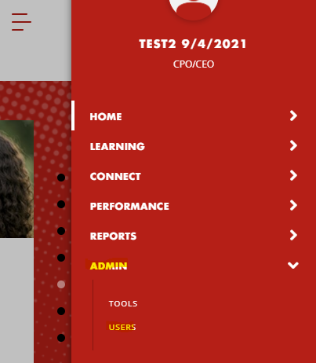
- On the Users page, type in the last and/or first name and click on the Search button. You can view all staff by leaving all fields blank and clicking on the Search button.
3. Locate and select the desired user by clicking on the name to view the individual’s User Record.
- Click on the Edit Record button. | 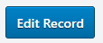
- Click on the arrow to display the custom field section of the user’s record.

BEFORE

AFTER
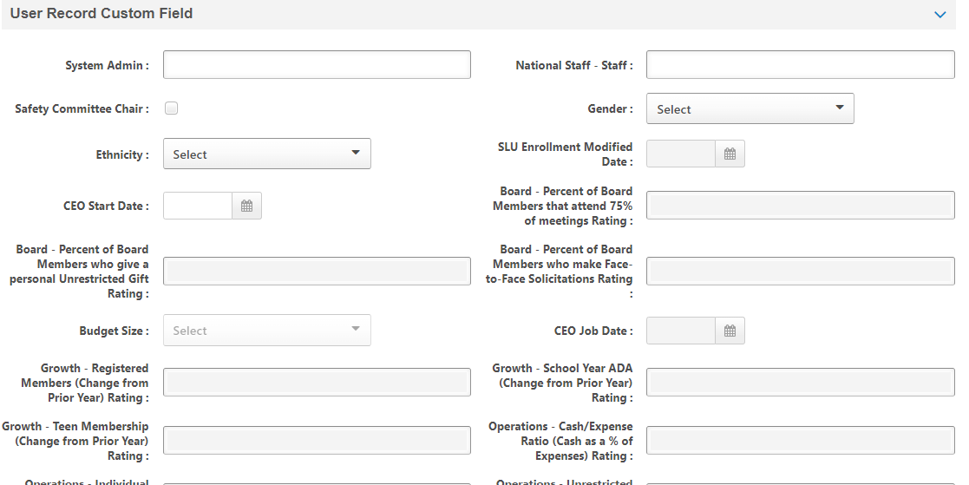
- Select the CEO Delegate box to add the Org Admin permission.
- Deselect the CPO Delegate box to remove the Org Admin permission.
- Click on the Save button to save selection and Cancel button to cancel selection (located at bottom of page).
IMPORTANT NOTE: It may take a few hours for the user to gain access to the Org Admin functionality. Please have them check back later, up to 6 hours.

Bulk Participation Enrollment of Fee Based Instructor-Led (ILT) Training Sessions
The following section provides the steps necessary to bulk register your staff to any fee based ILT training session, including Virtual ILT (VILT). This function is currently only available to registering for ILT/VILTs with registration fees associated to complete registration.

Purchasing Session Seats for Others
Org Admins now have the option to purchase session seats on behalf of your Club staff so that they do not have to incur out of pocket expense to attend a session. This is accomplished via a feature called Inventory Management. You first purchase one or more seats/licenses for the training session and then you choose which of your club members will take those seats.

To Purchase Inventory for a Session:
- Search for the ILT Event/Session via global search, events calendar, Browse for Training, etc.
- Click the Add to Cart option for the session you wish to purchase.
- The Add to Cart pop-up window opens. You will then see a radio button option to purchase this training for others. Click that radio button and enter the number of seats you are purchasing.
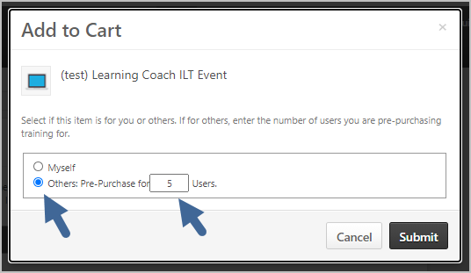
- Click the Submit button to continue.
- Confirm order and click the Proceed to Checkout button when ready.
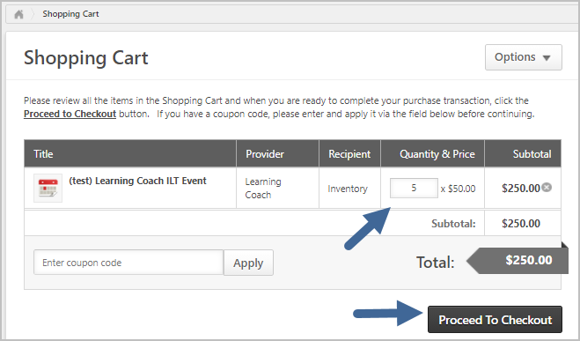

- You arrive on the Payment screen
- Click the Payment Method selector and choose PayPal.
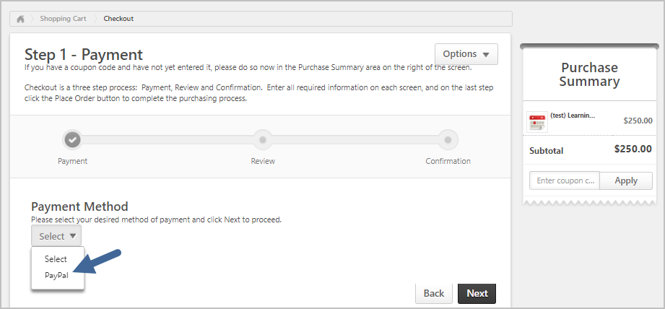

- The screen refreshes, displaying instructions on paying via PayPal. Click Next to continue.
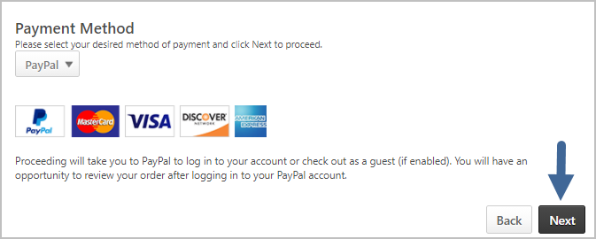
- You are taken to the PayPal site where you can enter your payment information. You may either log in to PayPal if you have a PayPal account, or check out as a guest, paying by credit or debit card. Follow the PayPal instructions to submit payment. Upon payment you are redirected back to SLU, on your transcript screen, and your purchase is complete.
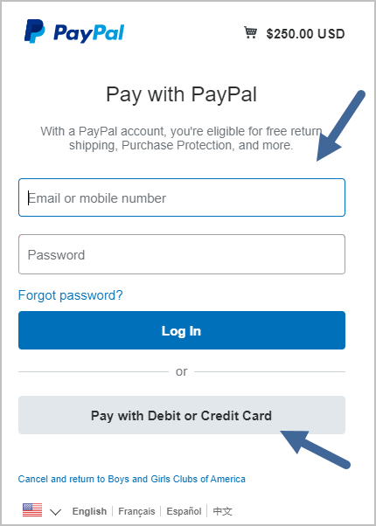
- You will receive purchase confirmation emails from both SLU (showing the details of what you purchased) and PayPal (confirming that you made a payment to BGCA through them).

Example of the SLU Purchase Transaction Confirmation Email

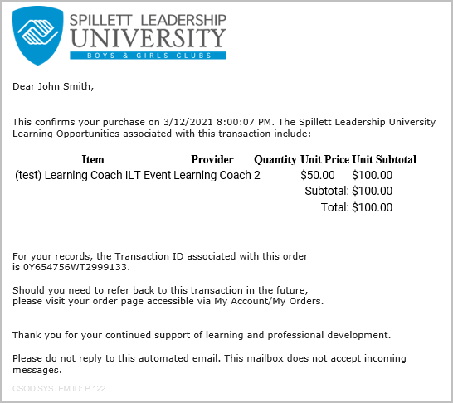

Assigning Your Inventory Seats
As soon as your inventory purchase is complete, you may begin assigning your purchased seats to your organization’s Club staff of choice. To access your inventory and assign seats to people:
- Hover your mouse on the Universal Profile in the top left corner of the portal and click on the name or picture to access the Universal Profile to gain access to the My Account information.
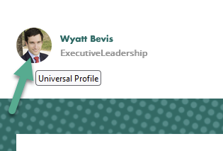

- You arrive on your My Account Settings screen. Click on My Orders from the side menu.
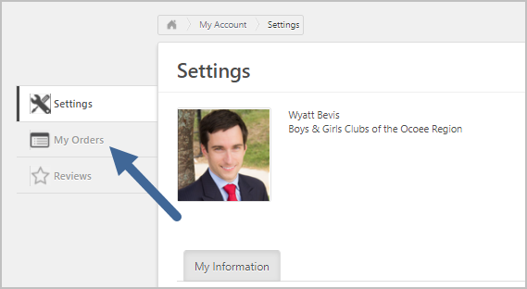

- From the My Orders screen, click the View Inventory button that appears on the top right.
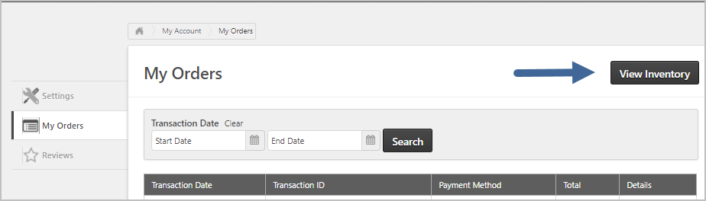
- Your Training Inventory screen appears, showing all inventory purchases you have made. For each purchase, it displays what training title/session was purchased, quantity purchased, quantity assigned to learners, and quantity remaining for assignment. Click on the down arrow icon (Assign Users) to distribute unused seats to learners.
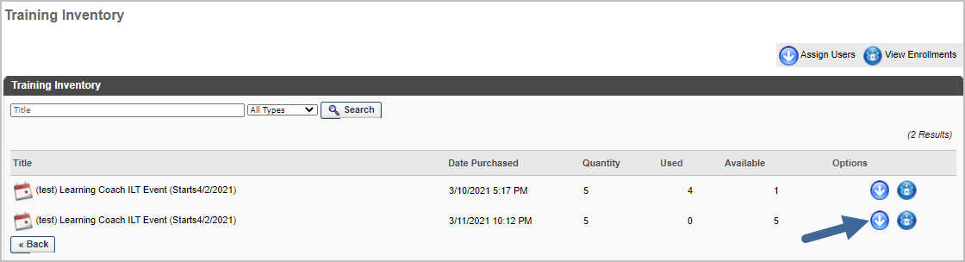

- The Assign Training screen opens. Check boxes next to the names of people who should attend the training you purchased. You do not have to assign all seats at once. You may return to this screen at any time to continue assignment. In the upper right of the screen, it shows how many seats you have left to assign. Click the Submit button at the bottom left of the screen when all assignees are chosen.
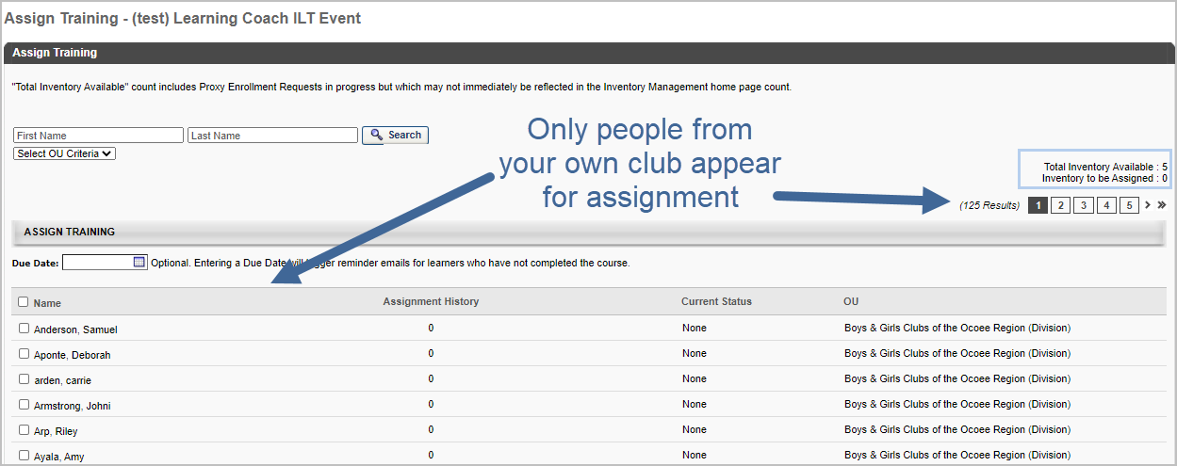
- You are returned to the main Training Inventory screen. Be aware that your new assignments take a few minutes to show up here (the system needs time to push those assignments to the people’s transcripts.) If you return to the screen after five minutes, they should appear (if not, wait a little longer in case there is a delay.
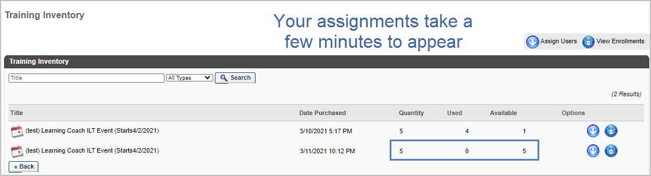
- When these inventory assignments are completed, the learners you chose will be registered for the session and will receive a confirmation email from SLU.
- Click on the View Enrollments icon to view a list of all people who were assigned one of your inventory seats. Be aware that on this screen it shows every user who was EVER assigned one of your seats, even if they later withdrew from the session. If you click the Options icon for a learner who appears on this screen, you can see whether they are still registered for the session. Do not worry if the number of assigned learners on this screen appears to be more than you purchased. The system is keeping track of withdrawals, substitutions and reassignments and will not let more seats be assigned than are purchased.
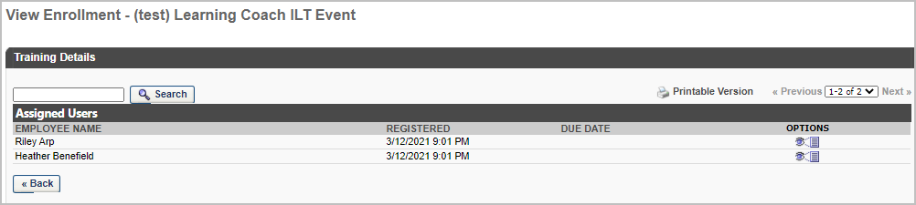

Inventory Management FAQs
Question | Answer
If I assign one of my inventory seats to someone who later withdraws from the class, can I assign the seat to someone else? | Yes. If an assigned learner withdraws from the session, the system credits that seat back to your inventory balance so it can be assigned to another learner.
I assigned several inventory seats to people from my club, but my Training Inventory screen does not reflect the assignment – my used and available seat balances have not changed. What is wrong? | It takes several minutes for the system to update your Training Inventory screen. It processes the assignments and registrations and then updates your inventory screen. Wait 5-10 minutes and return to the screen and all should be well. If you return and it still does not reflect the change, you may have forgotten to click the Submit button in the bottom left of the screen to complete the assignment. If you go back to the assignment screen and those people’s names still appear for assignment, then your assignment was not completed. Try it again and be sure to click the Submit button before leaving the screen.
I purchased 5 inventory seats for a session and assigned them, but the View Enrollment screen shows more than 5 people. How is that possible? | The View Enrollment screen lists every learner who has ever been assigned one of your inventory seats, even if they later withdrew. If you do not recall reassigning a seat after someone withdrew, it may have occurred via a substitution by an administrator. In substitutions, the admin swaps one learner for another in the session. Drill into details to see a user’s current session status.

Reviewing and Printing Previous Transactions in SLU
Any user may review and print previous transactions at any time from the My Account screen in SLU.
- Navigate to My Account via the Gear icon in the upper right corner of the portal.
- From the My Account screen, click on My Orders from the sidebar menu.
- Your previous transactions appear on the My Orders screen, sorted so that most recent order appears first.
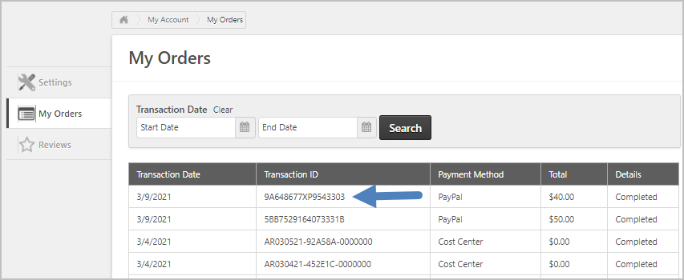
- The payment method appears. In practice, you can expect to see two possible payment methods on transactions:
  - PayPal – User paid via PayPal
  - Cost Center – There was no price for the training, so the user did not go through the shopping cart/checkout process.
- Click on a Transaction ID to view the details for that transaction.
- The transaction details appear. Click the drop down selector on the right side of the screen to print the order details.
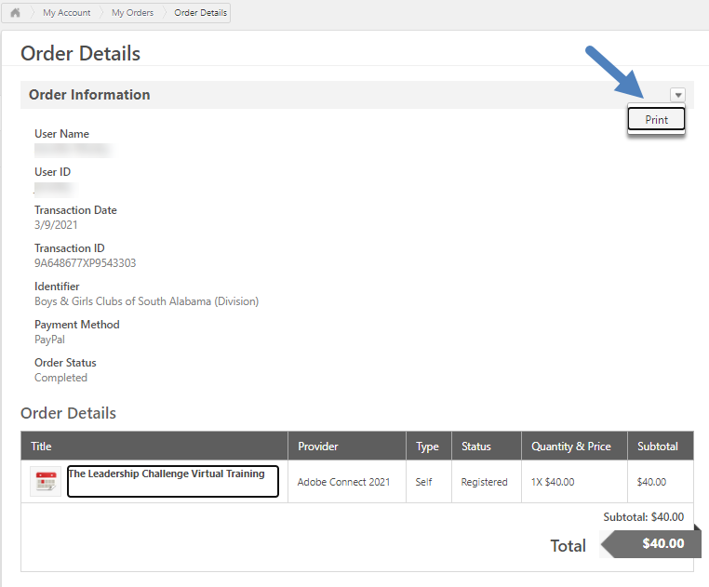

Substituting One Learner for Another on Session Rosters
There may be situations where a learner from your local club can no longer attend a session for which they are registered, but the roster is full, and you do not want to lose the seat to someone on the waiting list. In situations like this, you have the ability to Substitute another learner for the person who can no longer attend. Substitutions can be used whether the session has a price or not. In order for this to work, you must make the substitution before the learner withdraws on their own. If the learner withdraws on their own, it is too late for a substitution, and the next person on the waitlist (if any) gets the seat. If, however, the learner was assigned an inventory seat that you purchased, that seat is returned to your inventory and can be reassigned to someone else from your Training Inventory screen (see previous section). PLEASE NOTE: If this is fee-based training, a refund will be processed to the original registrant and will require the substitute registrant to resubmit payment to affirm his/her registration.

Performing a Session Substitution
Once you have identified who will replace the learner that can no longer attend, navigate to the transcript screen of the learner who will be replaced on the roster:
- Search for the registered learner via the Global Search field in the upper right corner of the SLU portal or by the steps indicated on Page 2.
- Click on that person’s name to view their Universal Profile and click the Transcript tab to see their transcript
- Find the session on their transcript and click the drop-down selector to the right and click the Substitute option.
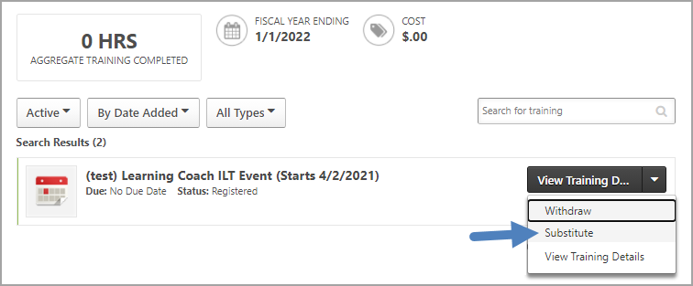
- The Substitute Training screen opens. Click the link that reads “Click to search for substitute employees.” Ignore the other two links; they do not apply.
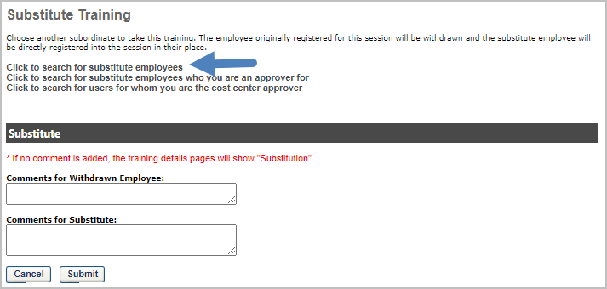
- The Find User popup window opens. Enter the Last Name and First Name of the person who will take the place of the person who cannot attend and click Search. Please be sure to select the correct user as there may be multiple people with the same name, but from a different Club organization.
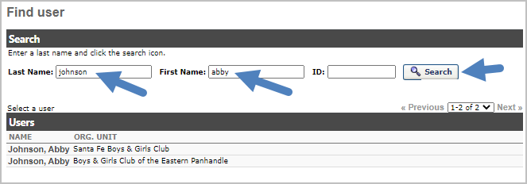
- Click on the name of the person who will be added to the session roster.
- The popup window closes, and the person’s name now appears as the substitute. Enter comments to the withdrawn and substitute learners to explain the action you took, if needed.
- Click Submit to complete the substitution.
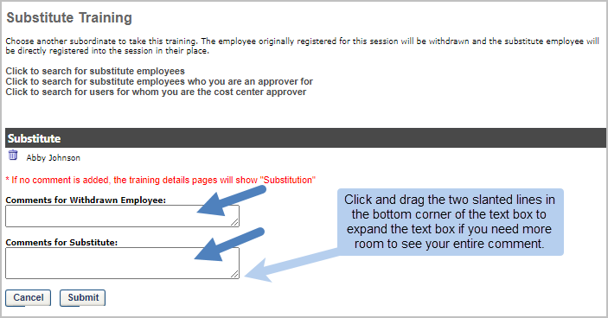
- You are returned to the transcript of the previously registered learner. Their session status is now ‘Withdrawn.’ If you no longer see the session on their active transcript, check their ‘archived’ transcript (via the drop-down selector at the top left of the transcript). The system automatically archives sessions in a status of withdrawn, to reduce clutter on the active transcript.
- The previous learner will receive a withdrawal confirmation email and the substitute learner will receive a ‘substitution’ notification email as well as a registration confirmation for the session. An example of the substitution email appears below. PLEASE NOTE: If this is fee-based training, a refund will be processed to the original registrant and will require the substitute registrant to resubmit payment to affirm his/her registration.
